Project Report

On

TRAVELLING WEBSITE

( Using HTML , CSS & Javascript )

(Session –2022-2023)



Under the Supervision of: Submitted by:

DR. Minakshi Bhardwaj SURYA SAINI

Name of the teacher Name of the Student

DR. Minakshi Bhardwaj SURYA SAINI

DR. Suman Dhull (Sub teacher) B.Sc. 6th Semester

Deptt of Computer Sc. Roll No.: 20055576

DAV COLLEGE, SECTOR 10, CHANDIGARH

DAV COLLEGE, SECTOR 10, CHANDIGARH

CERTIFICATE

This is to certify that Mr./Ms. **SURYA SAINI**, Class Roll No.**19018** a bonafide student of B.Sc. 6th Sem at DAV College, Chandigarh of batch 2022-2023 has completed the project entitled “_TRAVELLING WEBSITE USING HTML,CSS,JAVASCRIPT” under my supervision & guidance. It is further certified that the work done in this project is a result of candidate’s own efforts. I wish him/her all success in his/her life.

(Space for the Signature’s of the teacher)

Date:

Name of the Teacher. DR. Minakshi Bhardwaj

Deptt. of Comp. Sc. and IT

Acknowledgement

I am highly indebted and owe a sense of gratitude towards **Dr. Minakshi Bhardwaj.** Appointed to me as a Project Guide by the college, for giving me opportunity to learn a new subject but also to adapt it in a more practical way under her guidance.

Dr. Minakshi Bhardwaj HEAD OF DEPARTMENT OF COMP SCI. & IT supported me & patiently guiding me even at simple and small steps. Due to her support I’m able to complete this project & reached so far.

My sincere gratitude and thanks to **Dr. Rita Jain** Principal at DAV COLLEGE CHANDIGARH , for providing us such an environment with internet accessible computers and labs .

I am also very thankful to **Dr. Suman Dhull** class teacher/sub teacher because without her subjective guidance to me, I couldn’t be able to achieve practical excellence.

I am also thankful to all those who helped me directly or indirectly through their invaluable guidance and inspiration for successful completion of project

SURYA SAINI

|  |  |  |
| --- | --- | --- |
| SNO. | HEADING | PAGENO. |
| 1. | STATEMENT OF PROBLEM | 5 |
| 2. | SUMMARY OF PROJECT | 6-7 |
| 3. | OBJECTIVE | 8-9 |
| 4. | DESCRIPTION OF PROJECT | 10-11 |
| 5. | CERTAIN SPECIFIC REQUIREMENT | 12-13 |
| 6. | ARCHITECTURE DESIGN | 13-17 |
| 7. | BASIC HTML ,CSS & JAVASCRIPT | 18-19 |
| 8. | CODING (HTML , CSS & JAVA SCRIPT) | 20-47 |

INDEX

|  |  |  |
| --- | --- | --- |
| 9. | APPROACH USED | 48 |
| 10 | CONCLUSION | 48 |
| 11 | SCOPE OF THE PROJECT | 49 |
| 12 | BIBLIOGRAPHY | 50 |

Problem statement

The tourism industry faces a great challenge in the age of the information technology development. The traditional tourism distribution channel faces a threat of the emerging IT environment. Throughout years the tourism industry was dependent on the intermediaries, who enabled the interaction between the suppliers and the customers. Nowadays, however, the suppliers can reach the customer directly via internet having the geographical distance barriers and costs associated to them, disappeared. The internet age changed the complexity of the tourism distribution, enabling the entry of the new virtual intermediaries characterized by a strong competitive advantage towards other players of the sector.

The internet allows a wide range of benefits for the companies and the customers, making the information widely available, reducing the difficulties in purchasing, marketing and distribution, allowing the sellers and the buyers to direct transact with each other. However companies still face the difficulties on how to capture the benefits in order to position themselves in the digital reality. The entry of the new tourism intermediaries, known as the online travel agencies, introduced an innovative approach to the integration platform, collecting the suppliers and integrating them into a one stop shopping place for the customers. The success of the platform depends however on the participation level of the tourism products‘ suppliers. This raises the question of how to attract the various tourism suppliers to join the platform.

The thesis presents a cost/benefit analysis of the joining the platform for every participant. The analysis considers the financial aspects of the decision, but also the intangibles which should influence the long-term strategy for every tourism supplier (hotels, airlines, car rentals companies, cruises). The evaluation compares different distribution channels of the suppliers, both the traditional and emerging ones. The real life examples to support arguments presented are mostly based on the current world successful cyber-mediaries: Expedia, Travelocity and Orbitz.

1.1Summary of the Project:

Tours & Travels Management System offers solution to the different companies situated locally & globally in the many countries, states & districts and it organizes tours to various part of the particular areas. Earlier all the processes were done manually. The manual process is done by maintaining the details of the tours, employees and their customers.

1.1.1EMPLOYEE DETAILS:

Details of the employees of the system is maintained in the office. It includes details of both the moving staff (driver) and the non-moving staff (clerk). Details related to the salary of the employees is maintained. Salary of the clerk and the manager is calculated on the basis of monthly attendance and the salary of the driver is calculated on the basis of the trips made by the drivers. Salary of the employees are deducted on the basis of absence made by the employee. Details of no. of days the employee remained absent in a month is also maintained.

1.1.2 TOUR DETAILS:

Details of different types of tours which includes tours like family tours, couple tours, general tours, date and time of departure and the fair of the tours etc are maintained. As the customer ask for the details of a particular tour, the clerk gives the details of the related place where he/she wants to go and the date and time of the tour, no. of seats available of that particular tour, fair of the tour, details of discount on a particular tour package if any. Clark also guides the customer by giving the details of the forthcoming tours with the probable date and time. Details of types of bus like 3x2 or 2x2 for the tours. Details of total no. of days of the tour and the places to visit during the tour is also maintained. Details of the pick-up facilities and the drop facilities are also maintained if any.

1.13 Hotels Details:

Details of the hotels in which the accommodation of the customer will be done during the tours. Details like availability of meals, station-pickup and drop facility and contact detail of the hotels are also provided to the customers on special request.

1.2 PURPOSE:

Tours & Travel Management System is an application will help in maintaining the operations performed related to sight-seeing and travelling. Most of the people in this world like to travel from one place to another no matter whether it is a small or large distance. Some people like to travel by train, flight, bus or by any other means of transport. The tours travel management system application is designed for the travel agency in which there is an option of doing the railway or air ticket reservation in order to reach the intended destination. The tours & travel management system application is one of the applications that will help the customers to book the air ticket or the railway tickets through this application of the travel agency. Booking of tickets will be done with a great ease and without any difficulty. This will be one of the interesting projects that one can work on and implement in real time world. The user interface must be simple and easy to understand.

Objective

The main purpose of Tour and travels management system is to provide a best facility and travelling services for a customer to book hotels, flight and bus ticket for trip purpose. We have developed tour and travels management system to provide a search platform find their tour places according to their choices.

This is instead of to provide the best traveling services to the customers and travel agents.

We have expanded tours and travel administration strategy to provide an exploration platform where a tourist can find their trip spots according to their choices.

This method further assists to promote reliable and fascinating tourism so that people can celebrate their vacations in their favourite places.

This process also encourages to expanding tourism with different cultures, communities, so that they enhance the tourism experience, adventure, and build pride.

We create this system to establish and expand the structure of tourism that provides healthy interaction opportunities for tourists and natives and improves a Better awareness of different cultures, traditional lifestyles, traditional knowledge and moralities. This system moreover provides a better way to connect with various events.

This system also provides trip-related information like which spots are tourist attractions, cities, and regions. Tourists can also fetch the Map and navigation system and climate information.

This project is useful for tourists who are unfamiliar with the places where they want to visit. The application displays geographic-based data to the people shifting to the different cities and to the people who are ready to go on a journey.

9 | P a g e

The user can select any of the three choices available, which includes travel, food and accommodation facilities.

The user can view the orders placed and thereby provide the feedback regarding their experience and can share the images of the visited places.

It requires some time for working at their task but it is not much time-consuming. It is very efficient and reliable project. Our TMS deals with the visitors and travellers and other members of the organization. Since this is a real-time website, so the admin will be the director of the organization.

There are four modules in this software, now:

➢ Admin module:

1) Admin can manage the user and receive package from traveller & package management.

2) This module provides administrator related functionality. Administrator manages all information and has access rights to add, delete, edit and view the data related to places, travels, routes, bookings, etc.

➢ Travels Module:

1) This module provides the details of various travel agencies. A user can select the appropriate agency depending on convenience and accessibility.-

➢ Customer:

1. Customer can view package and booking.

2. This module helps to customer.

➢ Visitor:

1) Visitor view site and give feedback.

2) View site

Description of the steps:

In this phase, a logical system is built which fulfils the given requirements. Design phase of software development deals with transforming the clients 's requirements into a

logically working system. Normally, design is performed in the following in the following phases:

1. Primary Design Phase:

In this phase, the system is designed at block level. The blocks are created on the basis of analysis done in the problem identification phase. Different block scale created for different functions emphasis is put on minimizing the information flow between blocks. Thus, all activities which require more interaction are kept in one block.

2. Secondary Design Phase:

In the secondary phase the detailed design of every block is performed.

The general tasks involved in the design process are the following:

1. Design various blocks for overall system processes

2. Design smaller, compact and workable modules in each block

3. Design various database structures

4. Specify details of programs to achieve desired functionality.

5. Decision of the form of inputs and outputs of the system.

6. Perform documentation of the design

7. System reviews

**User Interface Design**

User Interface Design is concerned with the dialogue between a user and the

computer. It is concerned with everything from starting the system or logging into the

system to the eventually presentation of desired inputs and outputs. The overall flow of

screens and messages is called a dialogue

The following steps are various guidelines for User Interface Design:

1. The system user should always be aware of what to do next.

2. The screen should be formatted so that various types of information, instructions

and messages always appear in the same general display area.

3. Message, instructions or information should be displayed long enough to allow

the system user to read them.

4. Use display attributes sparingly.

5. Default values for fields and answers to be entered by the user should be

specified.

6. A user should not be allowed to proceed without correcting an error.

7. The system user should never get an operating system message or fatal error.

Certain Specific Requirements:

Below is a list of the minimum Hardware and Software requirements to access the basic website content.

Operating System:

• Windows 7, Windows 8 or Windows 10

• Mac OSX 10.8, 10.9, 10.10 or 10.11

Hardware:

• Processor (CPU) with 2 gigahertz (GHz) frequency or above

• A minimum of 2 GB of RAM

• Monitor Resolution 1024 X 768 or higher

• Internet Connection Broadband (high-speed) Internet connection with a speed of 4 Mbps or higher

• Keyboard and a Microsoft Mouse or some other compatible pointing device

• Sound card

• Speakers or headphones

Browsers:

• Chrome

• Edge

• Mozilla Firefox

• Internet Explorer (Windows only)

• Safari (MacOS only)

Browser Configuration:

Browser must be configured as follows:

• Strongly Recommended to trusted sites.

• JavaScript must be enabled

• Cookies must be enabled.

• Pop-up windows must be enabled.

Software:

• Microsoft Office--a free copy of Office 265

• Java -- To view and interact with all available blackboard applications.

• Real Player--for audio/video content.

• Quick Time--for audio/video content.

• PowerPoint viewer--PowerPoint Viewer lets you view full-featured presentations created in PowerPoint 97 and later versions.

• Adobe Shockwave--for Macromedia content.

• Adobe Acrobat Reader --for PDF files Adobe® Reader® software is the global standard for electronic document sharing. It is the only PDF viewer that can open and interact with all PDF documents. Use Adobe Reader to view, search, digitally sign, verify, print, and collaborate on Adobe PDF files.

• Adobe Flash Player--Flash Player allows you to enjoy content with video, graphics and animation.

Data Flow Diagram (architecture design)

A Data Flow Diagram (DFD) is a diagram that describes the flow of data and the processes that change or transform data throughout a system. The Data Flow Diagram reviews the current physical system, prepares input and output specification, specifies the implementation plan etc.

Four basic symbols are used to construct data flow diagrams. They are symbols that represent data source, data flows, and data transformations and data storage. The points at which data are transformed are represented by enclosed figures, usually circles, which are called nodes.

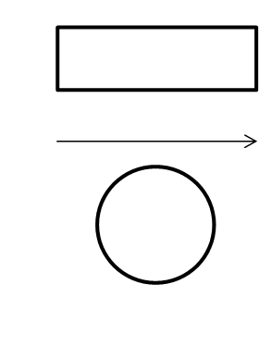

1. Source of Destination

1. Flow of Data
2. Process



(D) Storage Steps

to Construct Data Flow Diagrams

Four steps are commonly used to construct a DFD

• Process should be named and numbered for easy reference. Each name should be representative of the process.

• The direction of flow is from top to bottom and from left to right.

• When a process is exploded into lower level details they are numbered.

• The names of data stores, sources and destinations are written in capital letters

Rules for Constructing a Data Flow Diagram

• Arrows should not cross each other.

• Squares, Circles and files must bear names.

• Decomposed data flow squares and circles can have same names.

• Choose meaningful names for dataflow.

Draw all data flows around the outside of the diagram

Context Level Data Flow Diagram

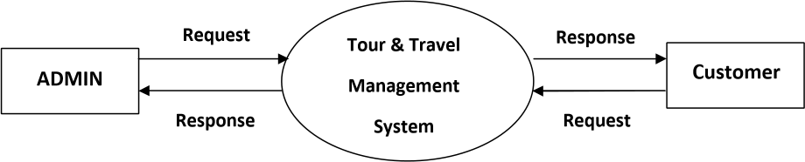



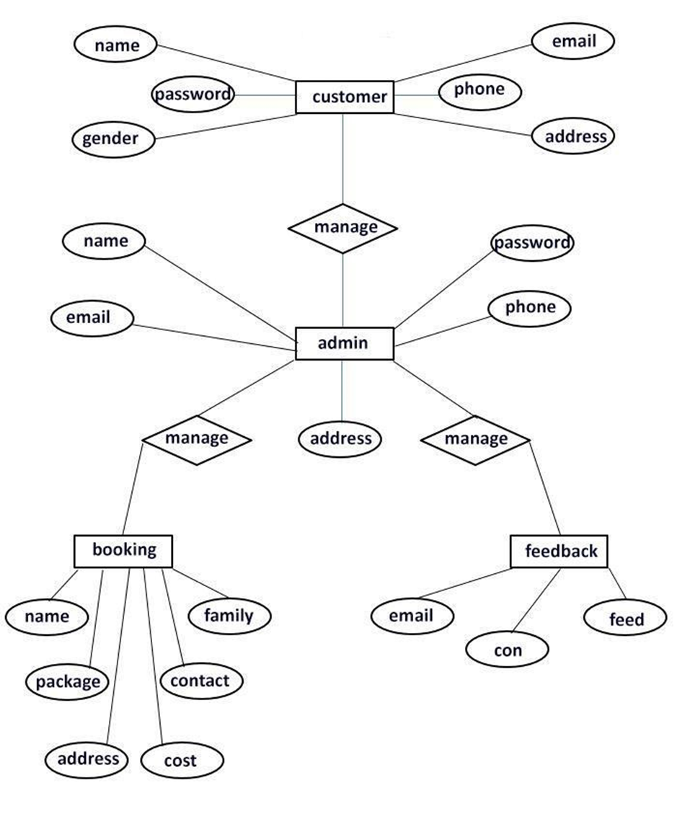ER DIAGRAM

Basic About Html , Css , Javascript

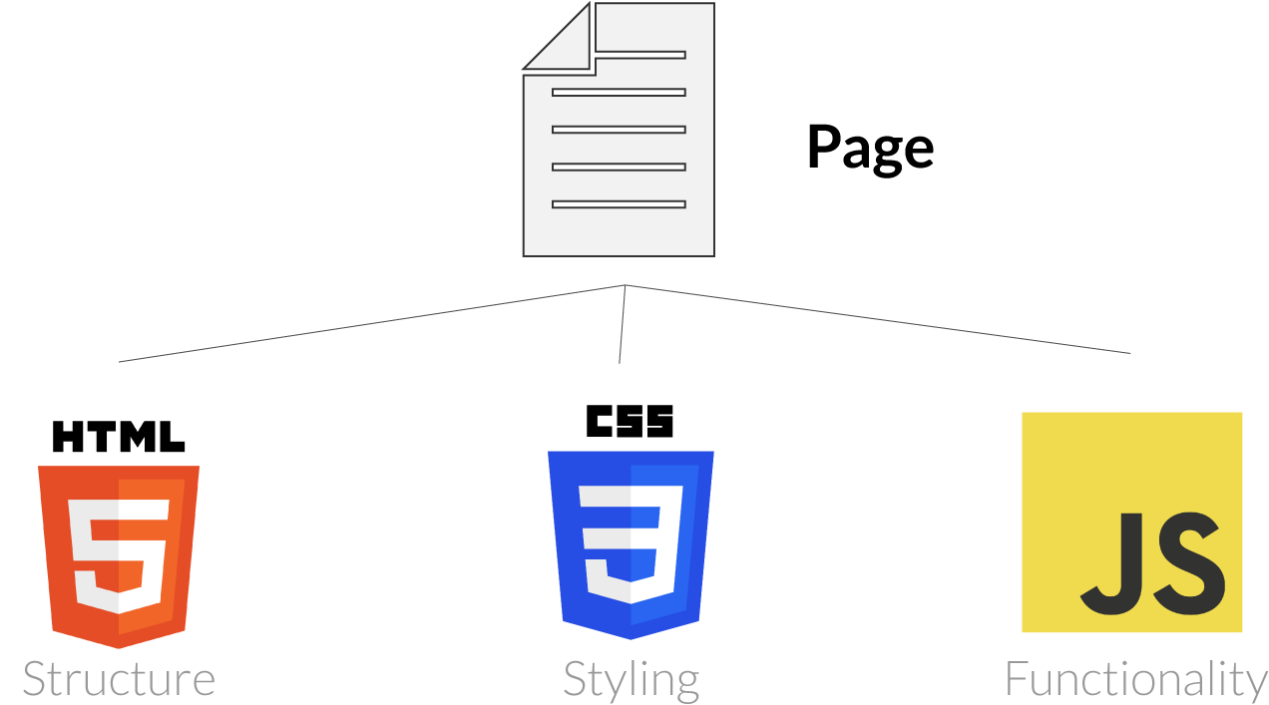

What is HTML?

* HTML stands for Hyper Text Markup Language
* HTML is the standard markup language for creating Web pages
* HTML describes the structure of a Web page
* HTML consists of a series of elements
* HTML elements tell the browser how to display the content
* HTML elements label pieces of content such as "this is a heading", "this is a paragraph", "this is a link", etc.

## What is CSS?

* CSS stands for Cascading Style Sheets
* CSS describes how HTML elements are to be displayed on screen, paper, or in other media
* CSS saves a lot of work. It can control the layout of multiple web pages all at once
* External stylesheets are stored in CSS files

## JavaScript Can Change HTML Content

* One of many JavaScript HTML methods is getElementById().
* The example below "finds" an HTML element (with id="demo"), and changes the element content (innerHTML) to "Hello JavaScript":

CODING

**SCREENSHORTS:**

**Header&NavBar**

**HTML USED:**

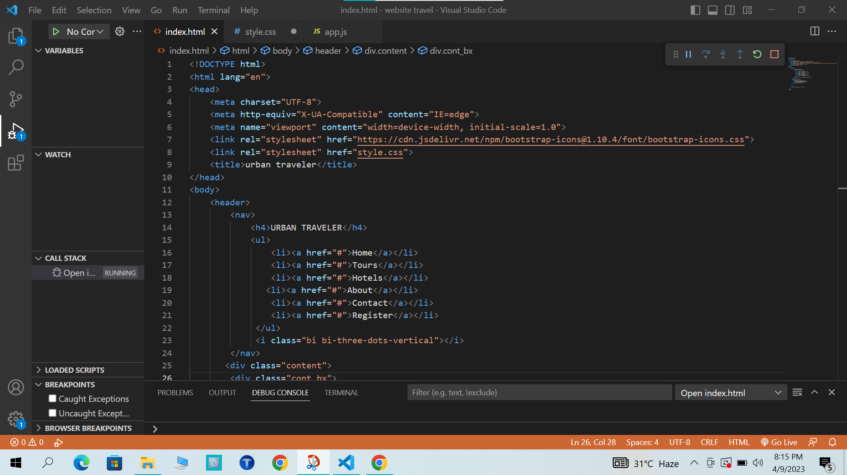

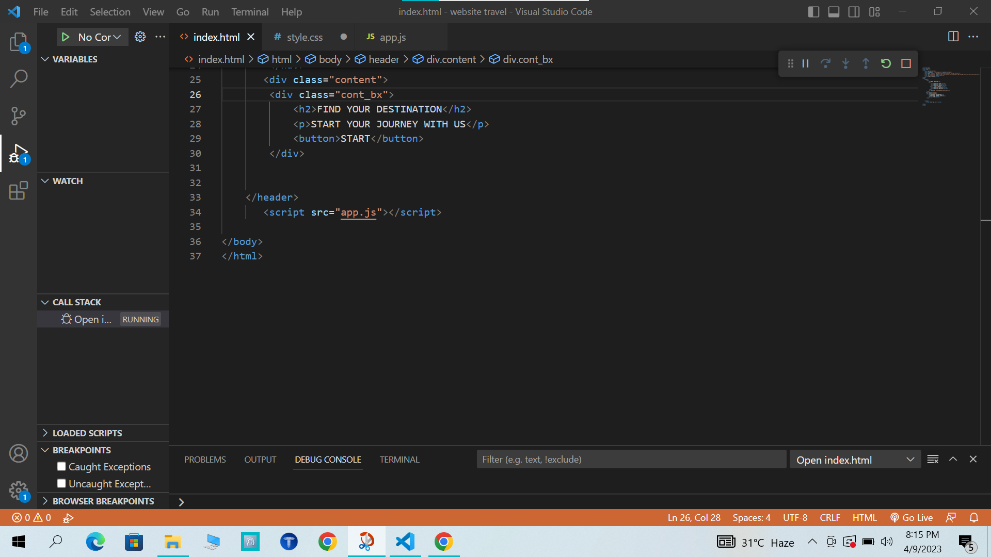

CSS For Header & Navbar

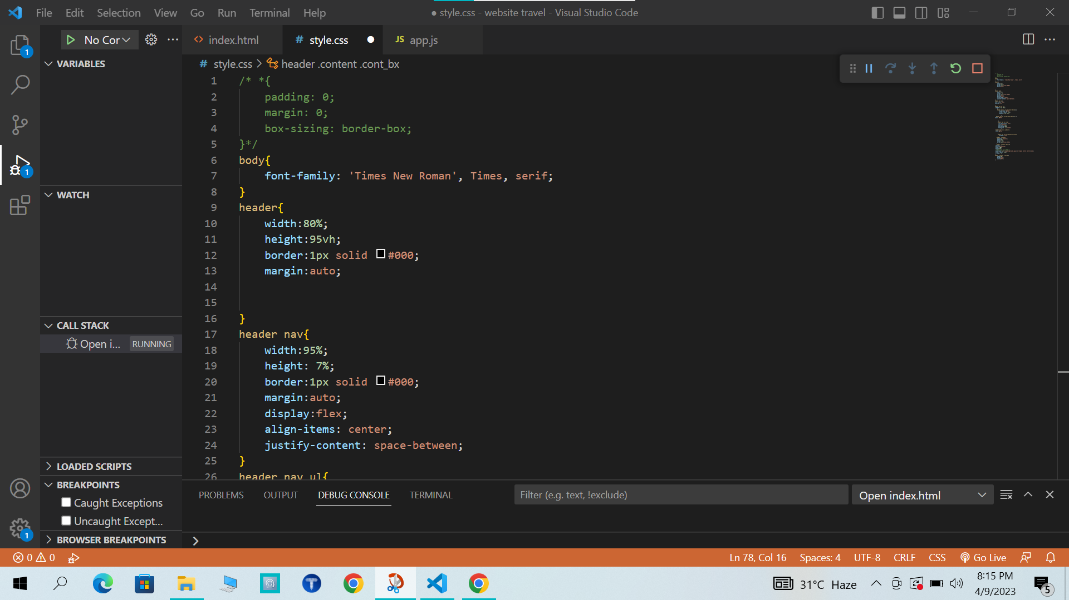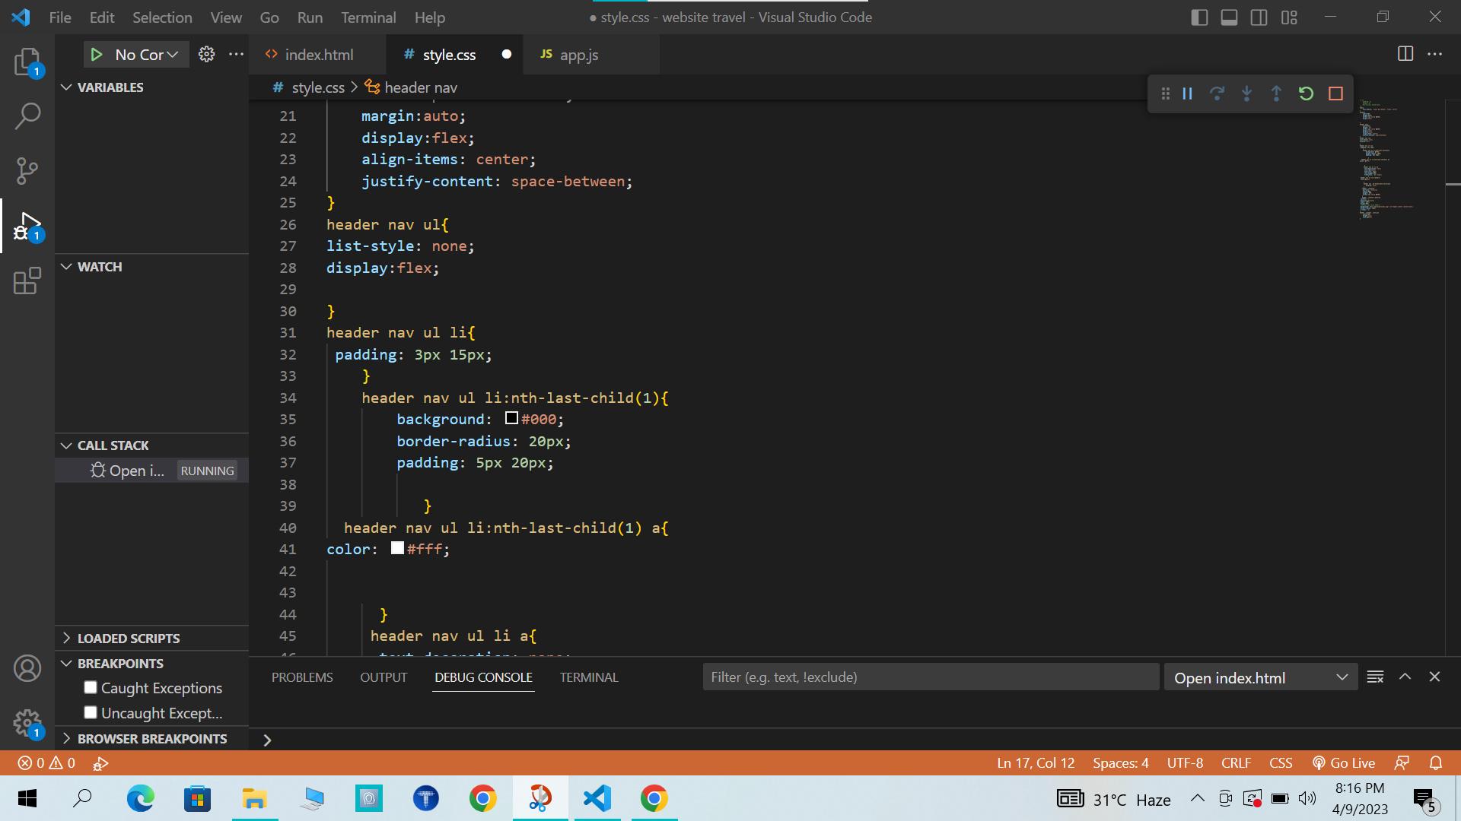

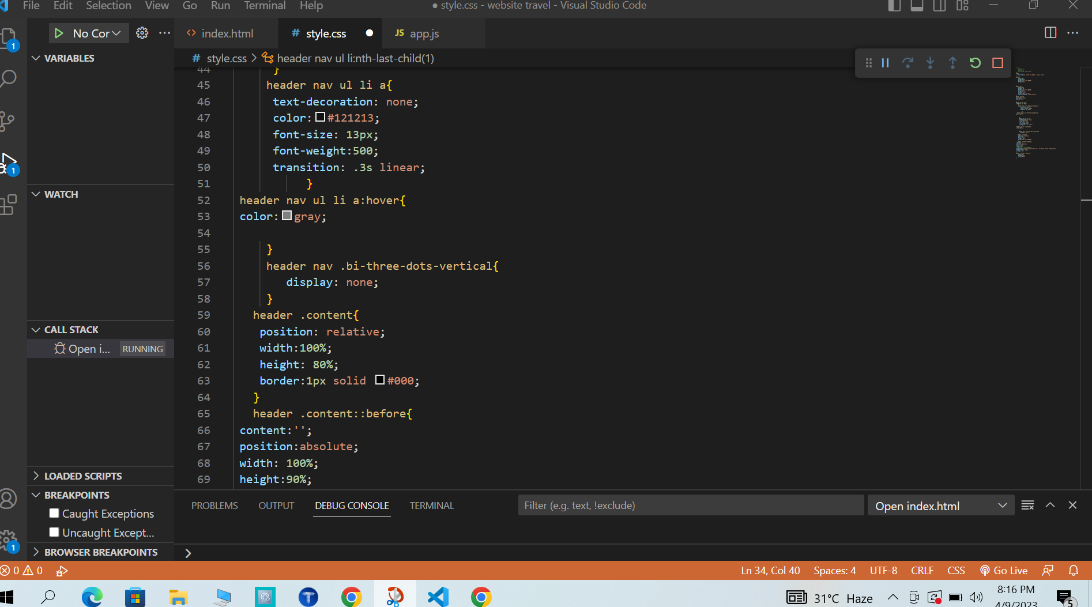

OUTPUT:

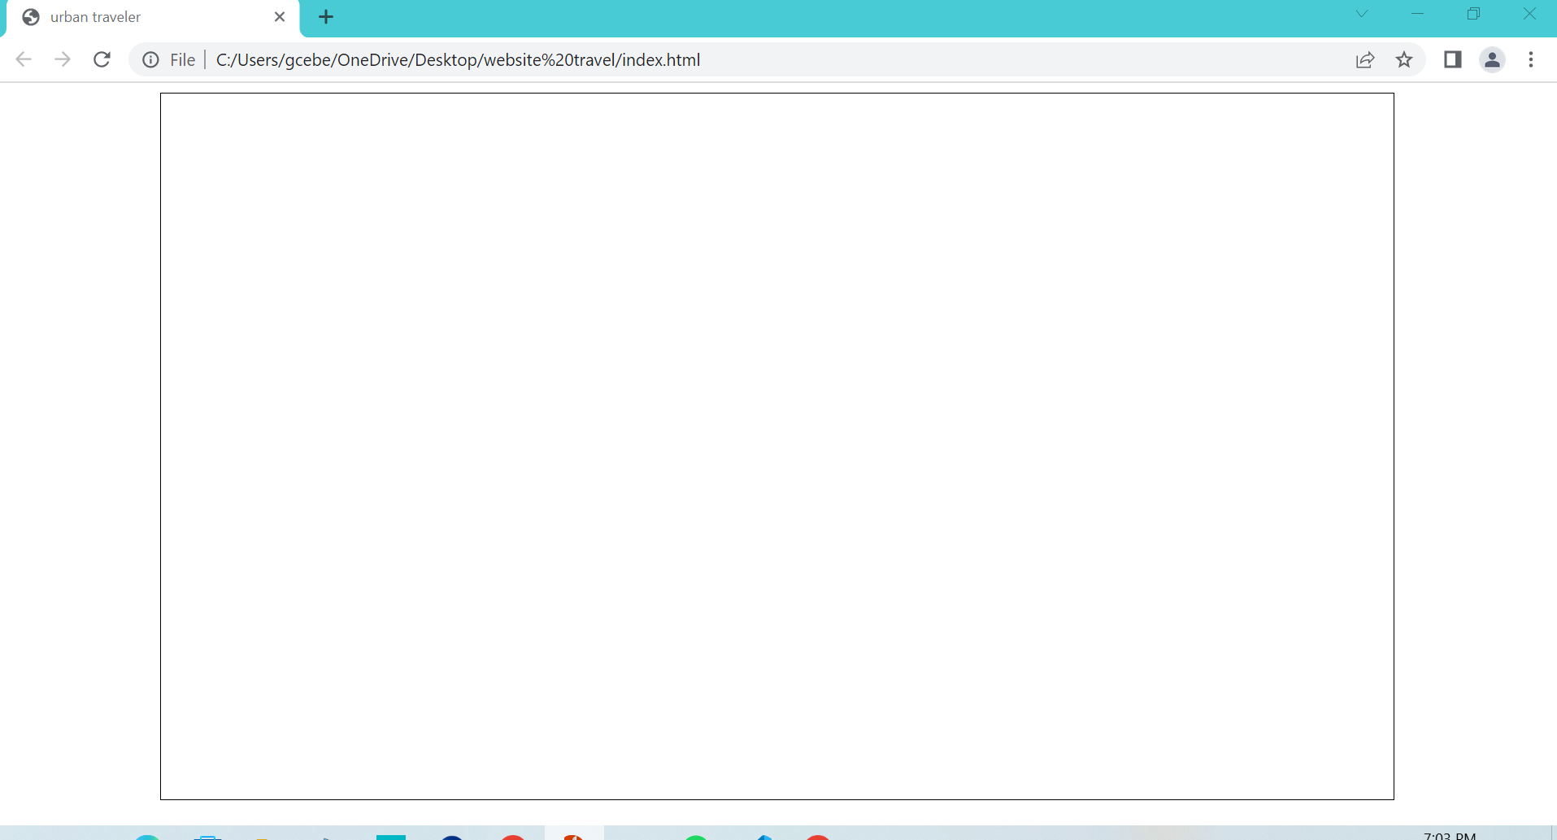

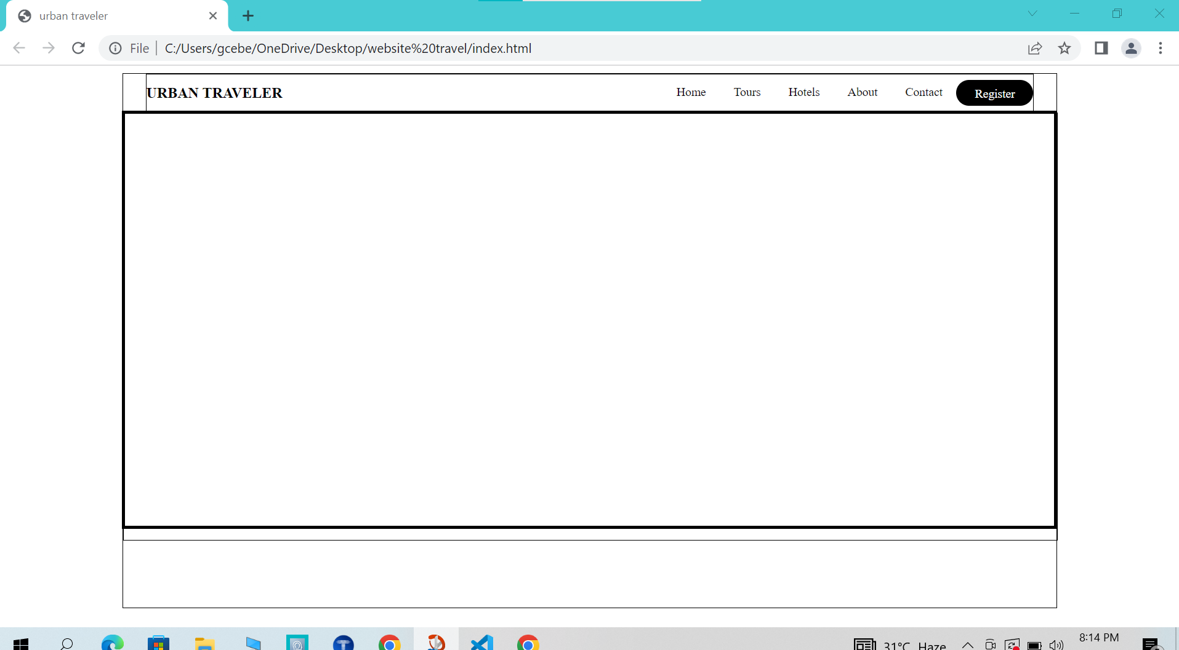

HTML For Content box:

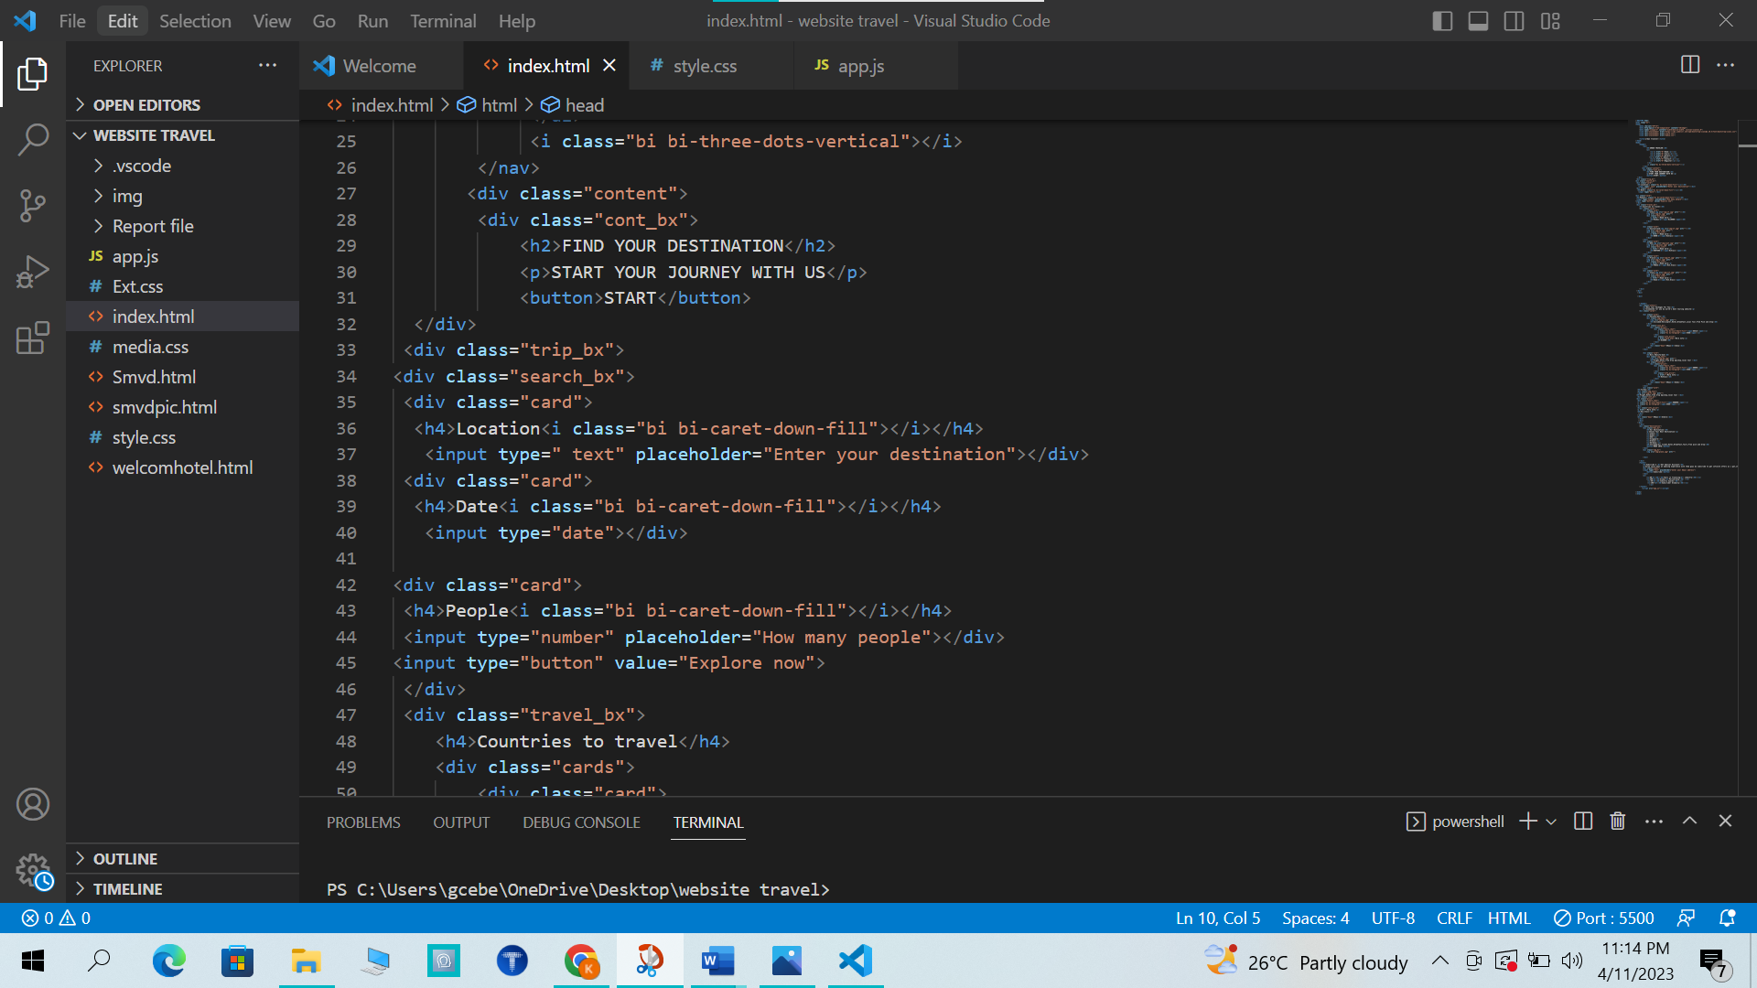

CSS For Content box:

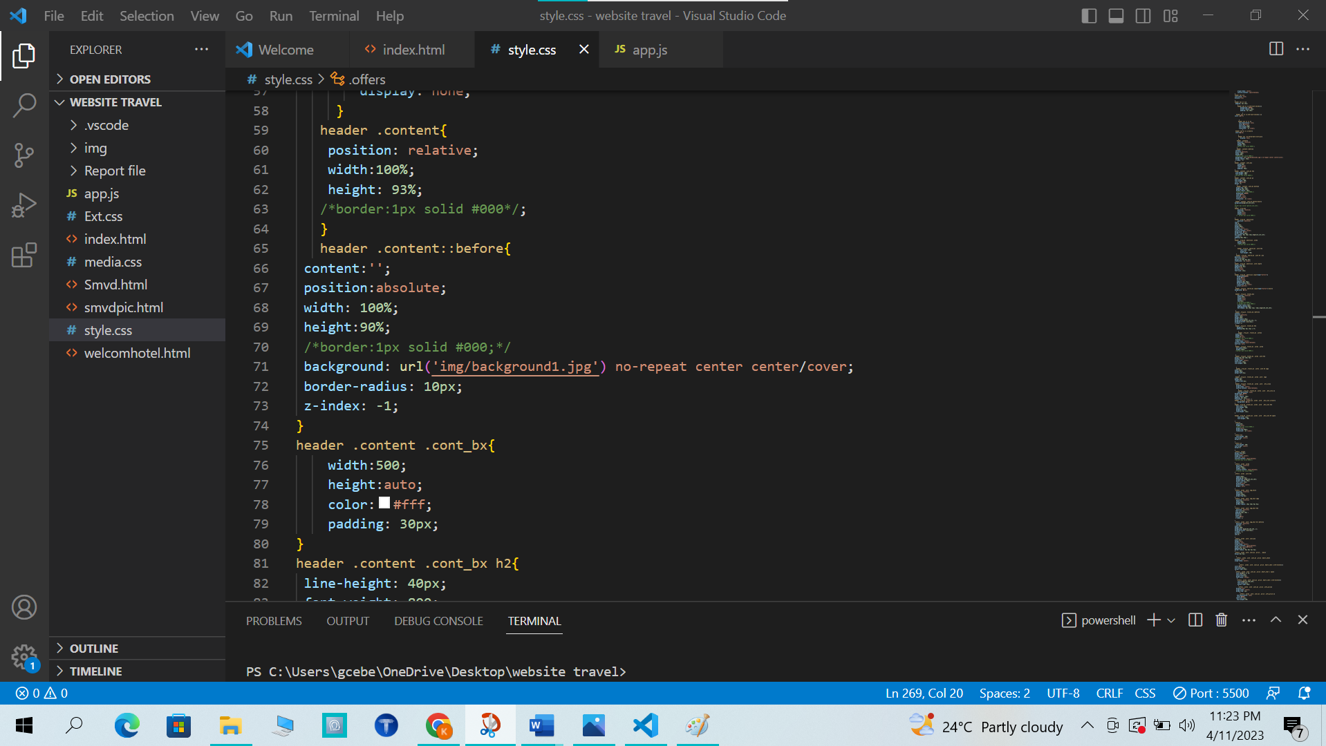

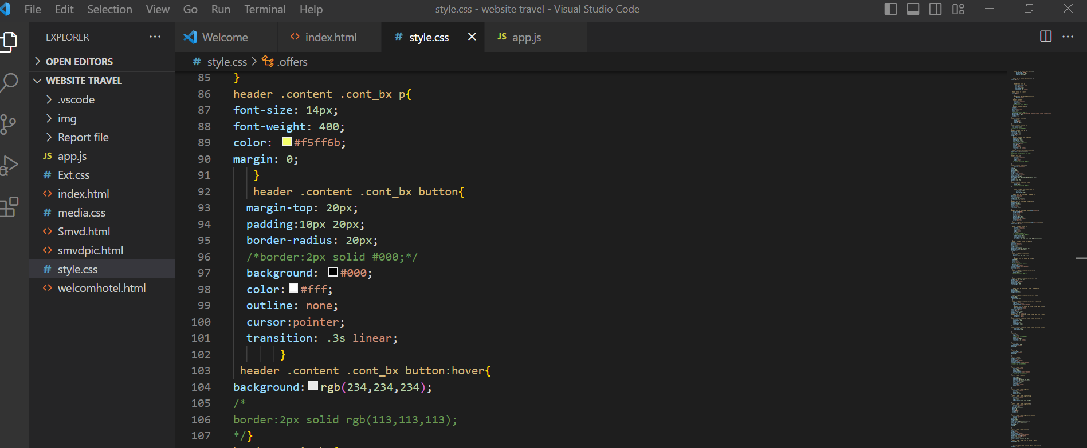

OUTPUT:

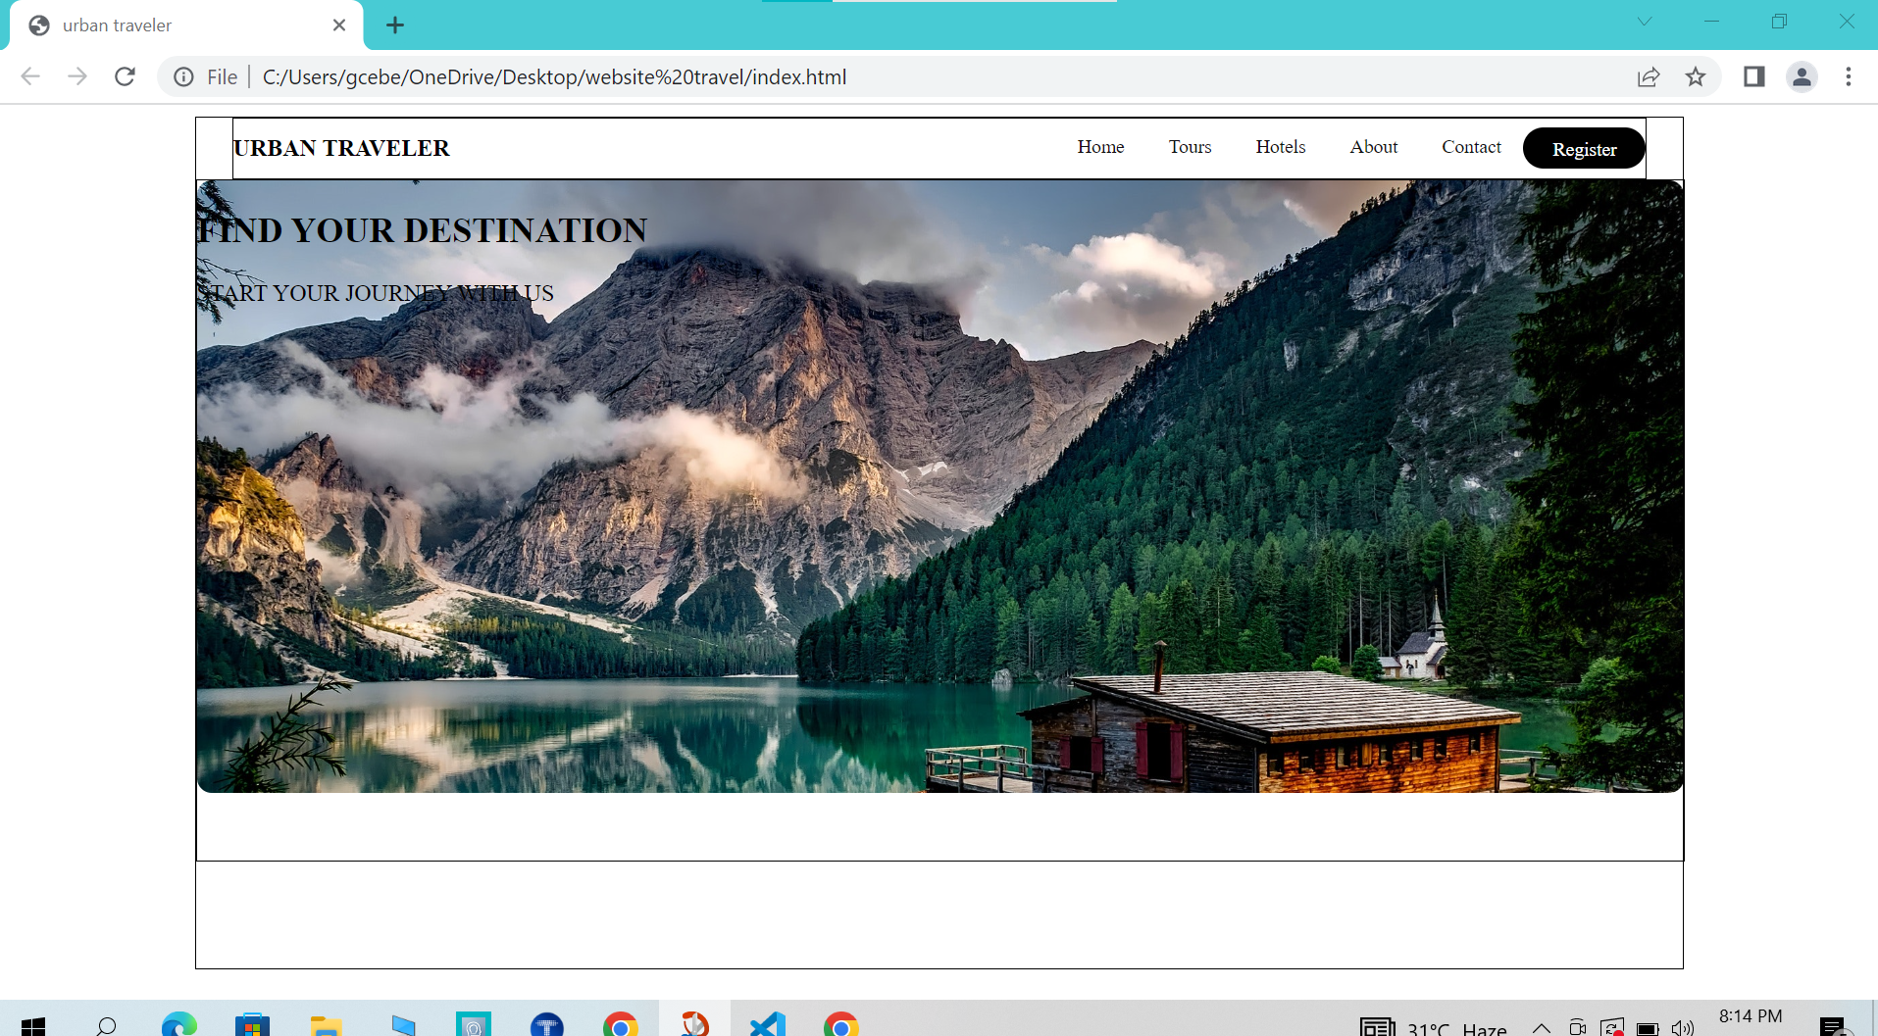

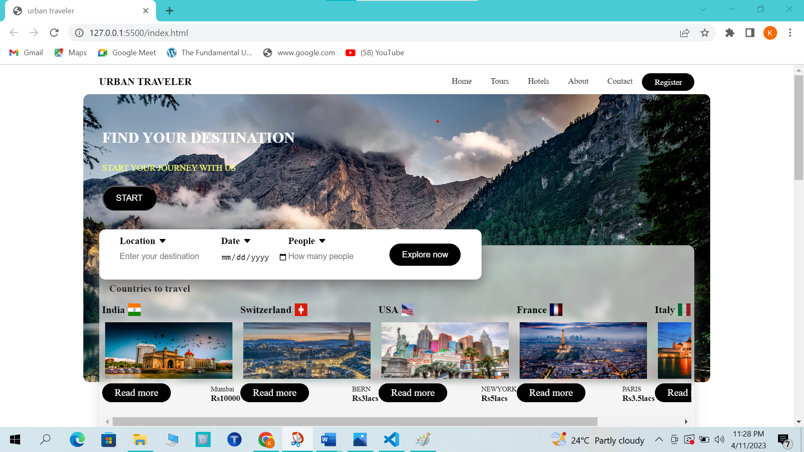For start button:

Html For Trip box, Search box &cards:

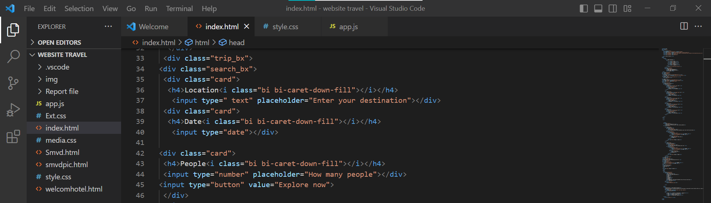

CSS For Trip Box, Search box& cards;

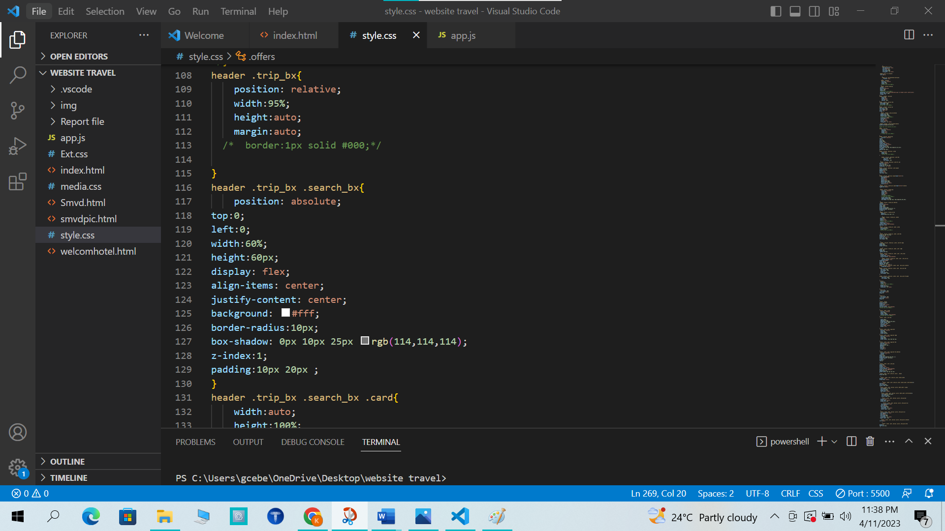

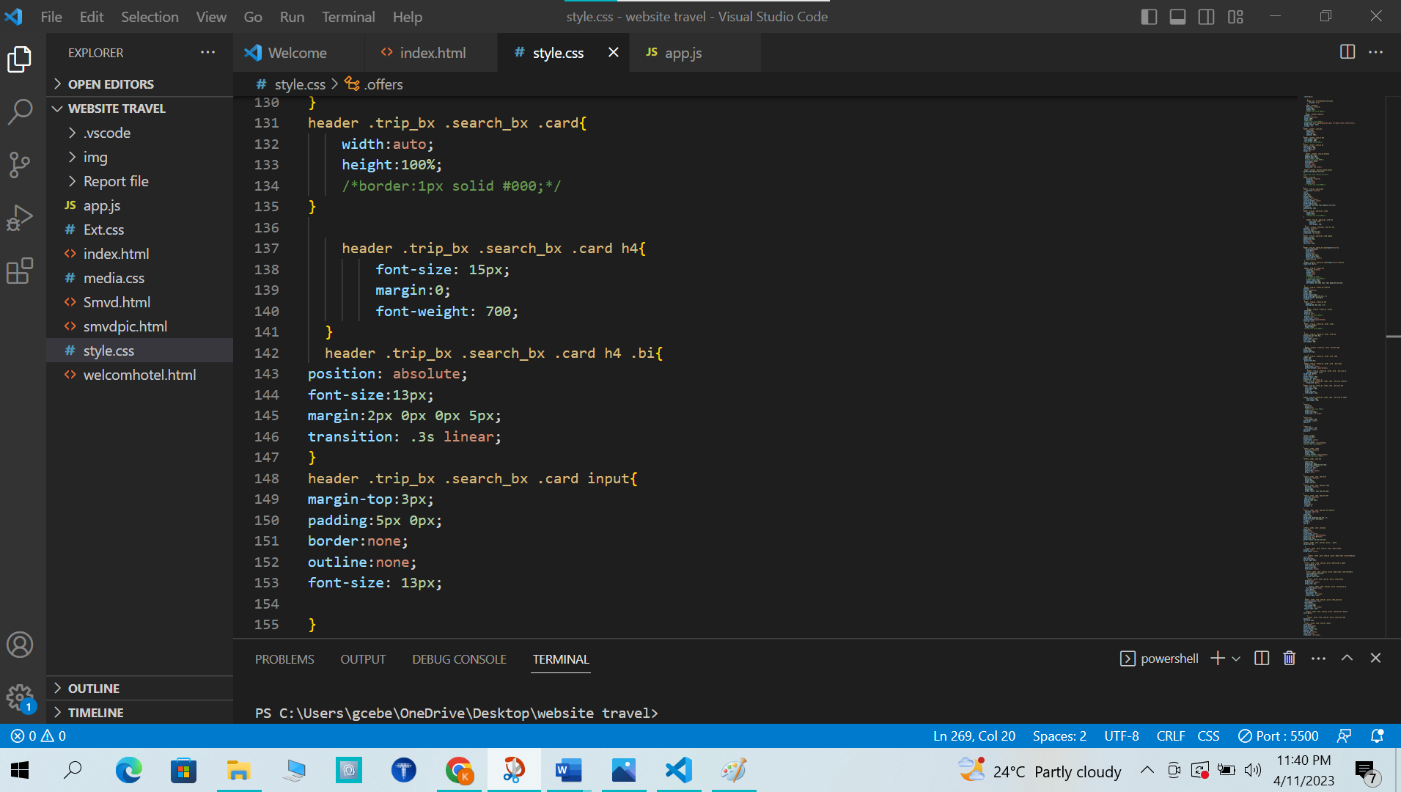

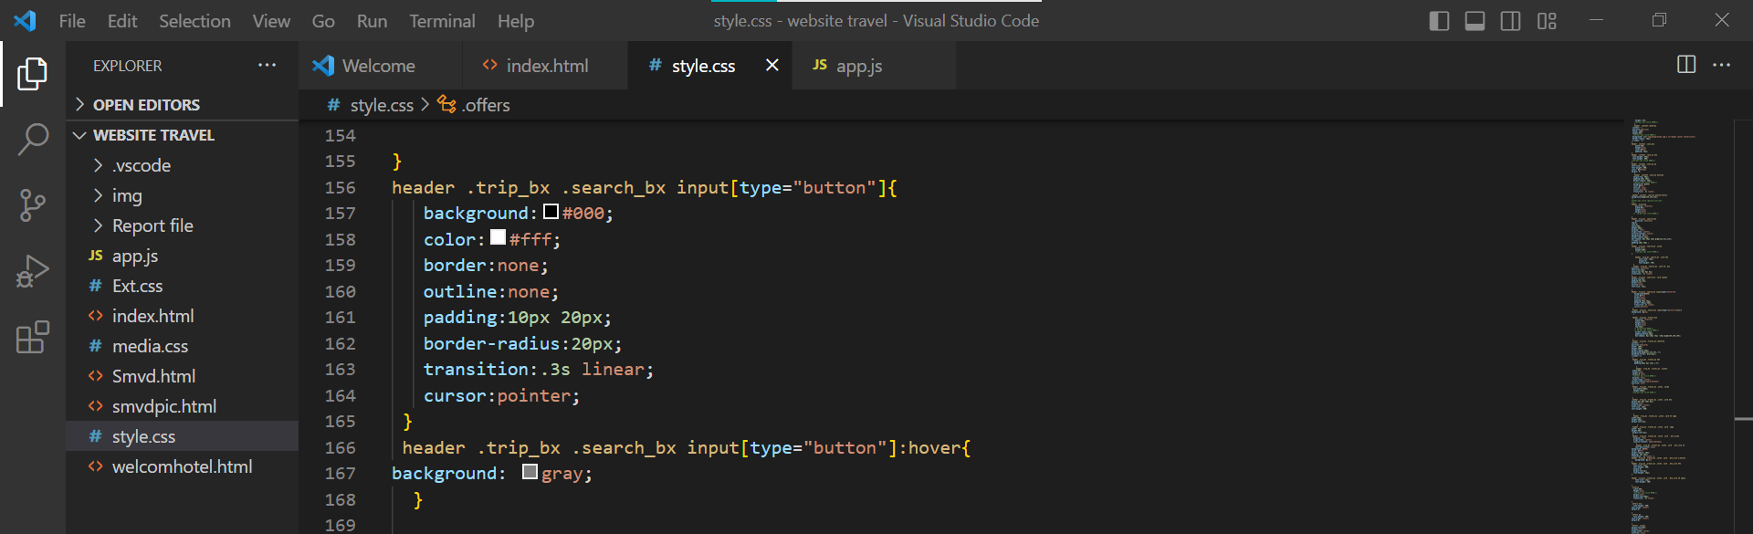

OUTPUT:

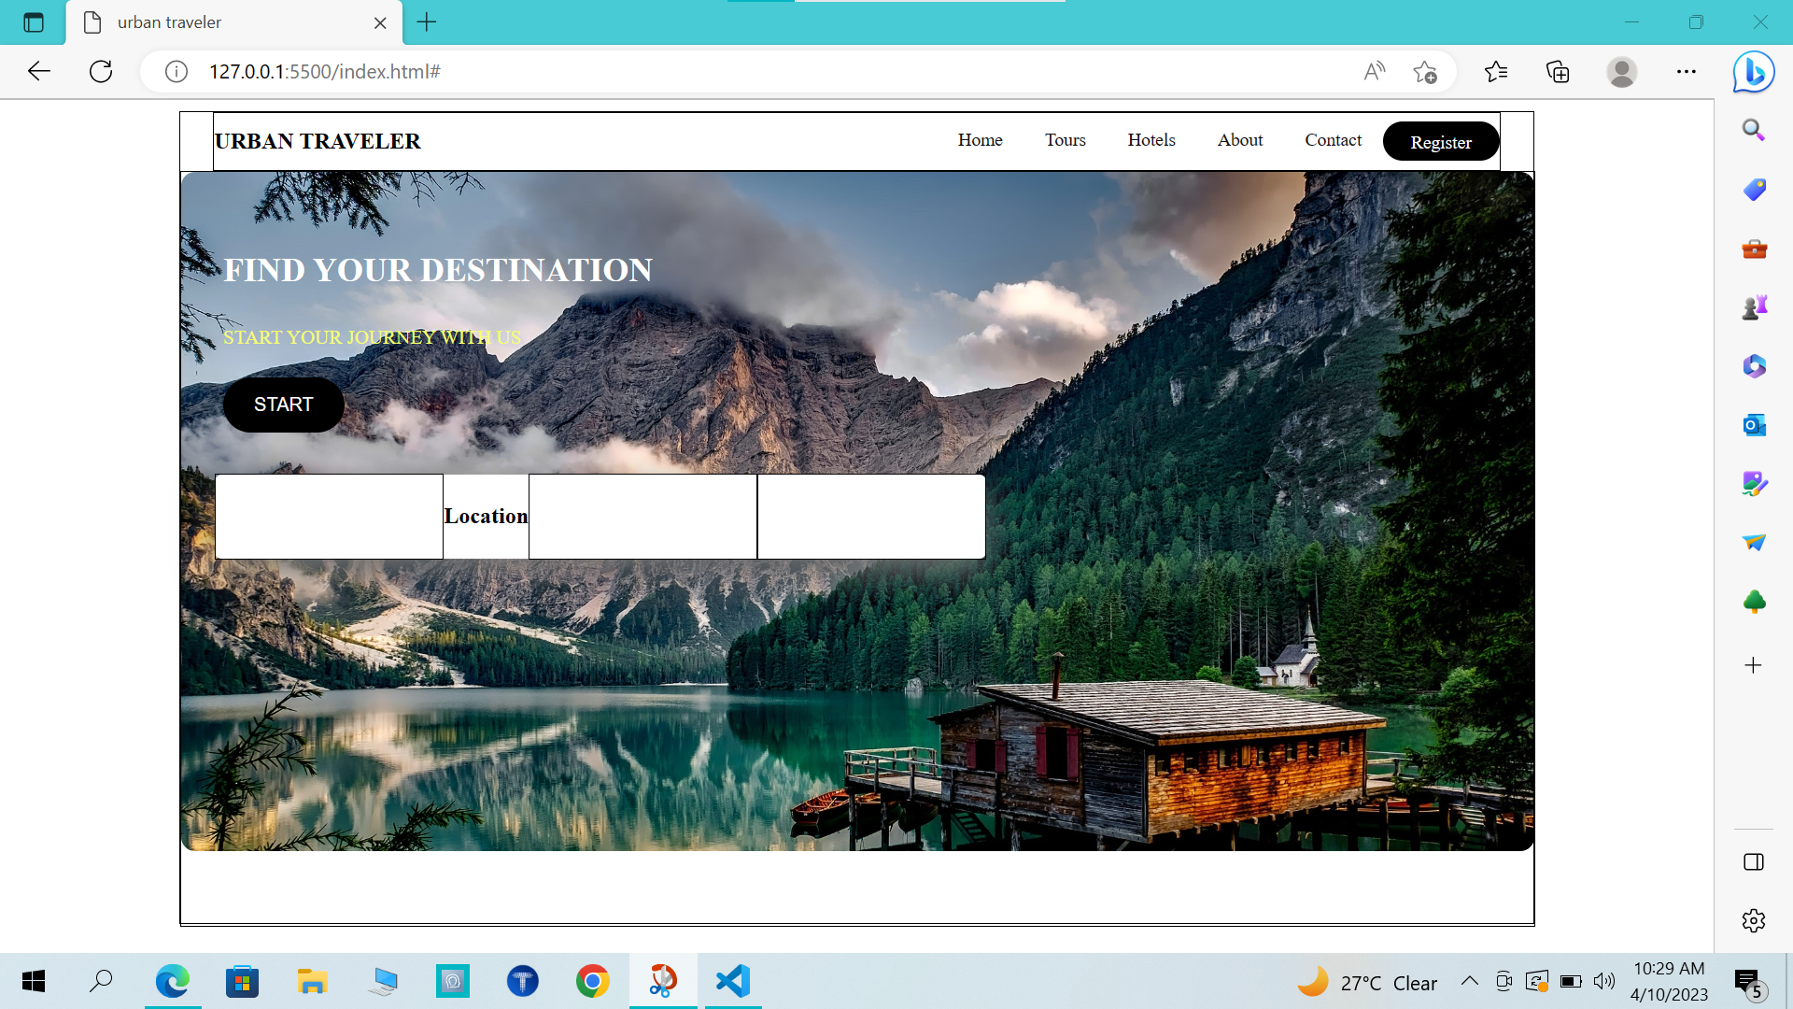

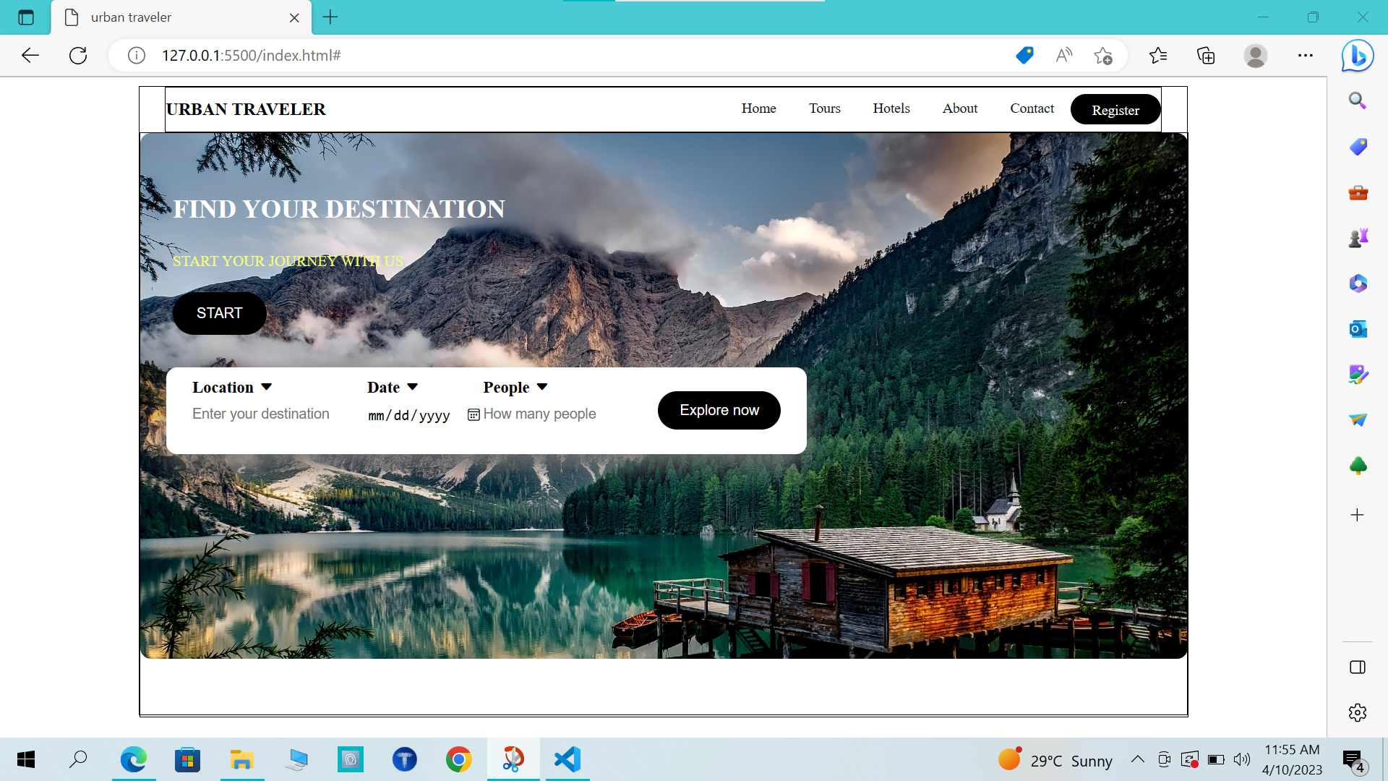

JAVASCRIPT For Search Box:

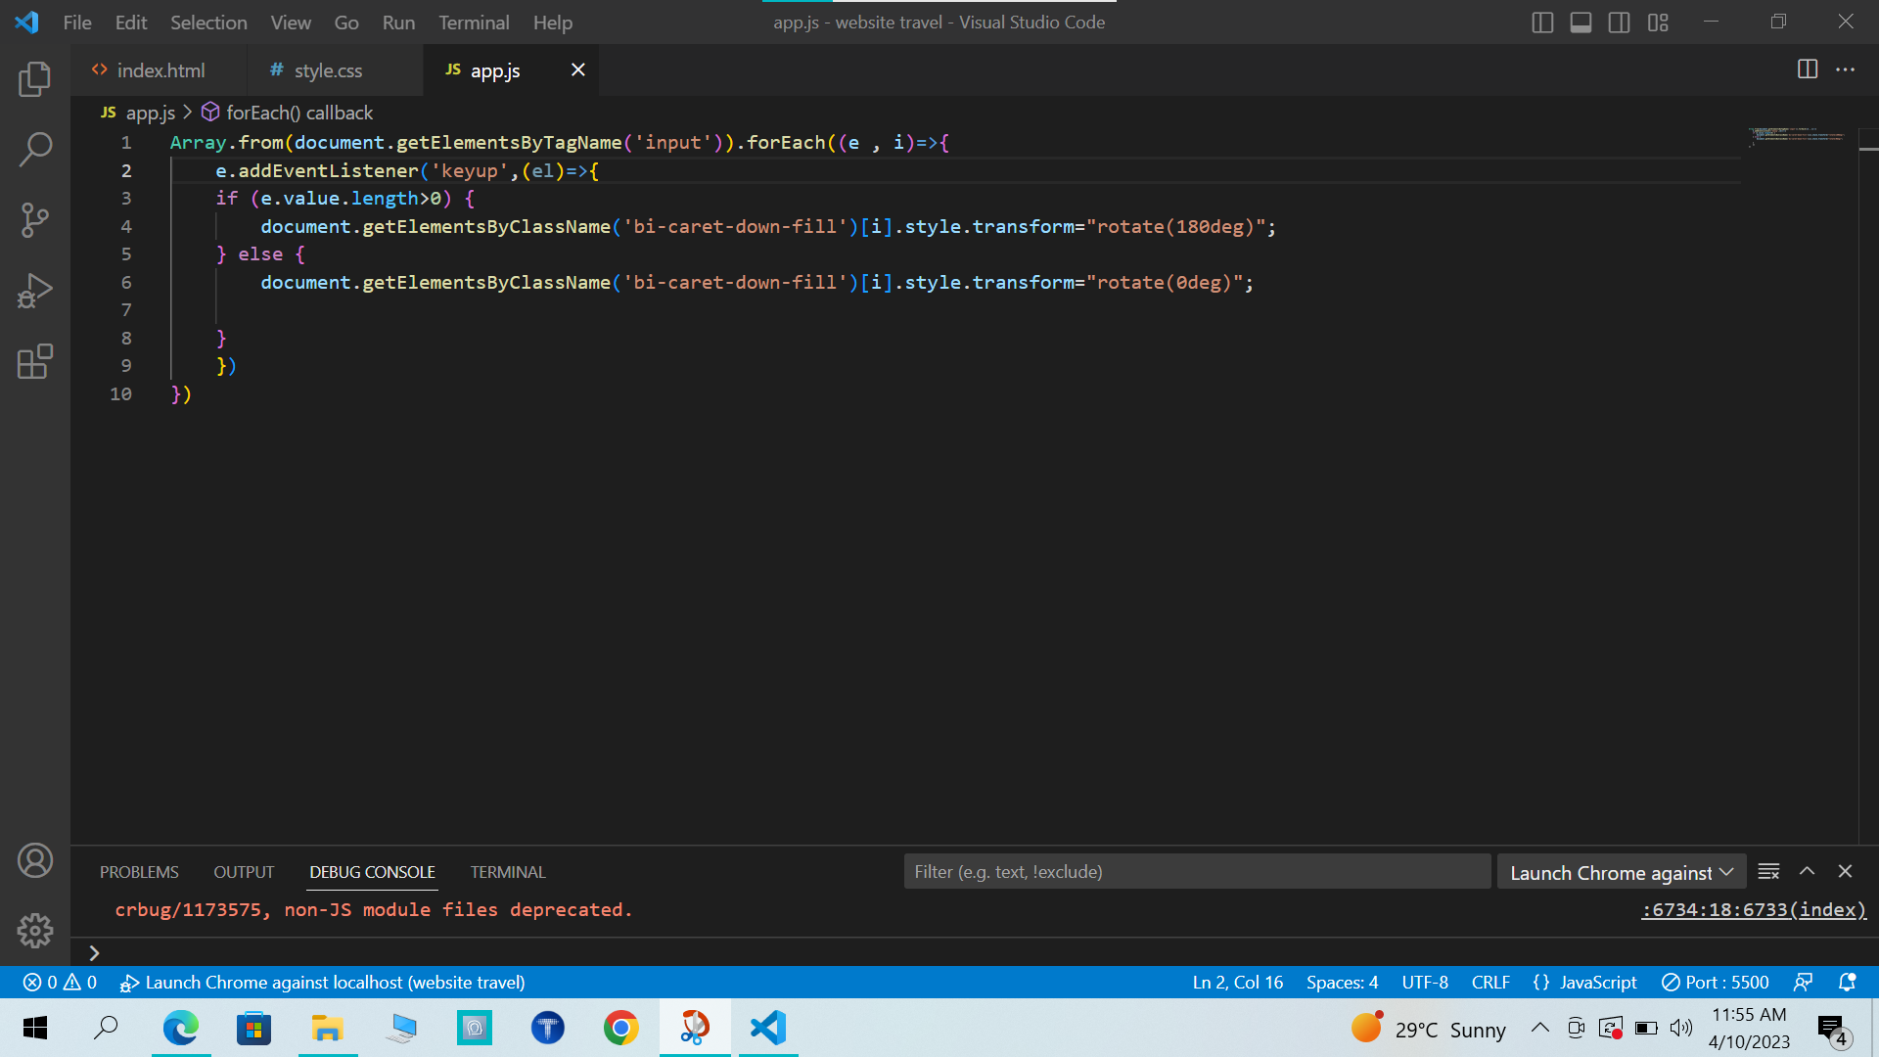

OUTPUT:

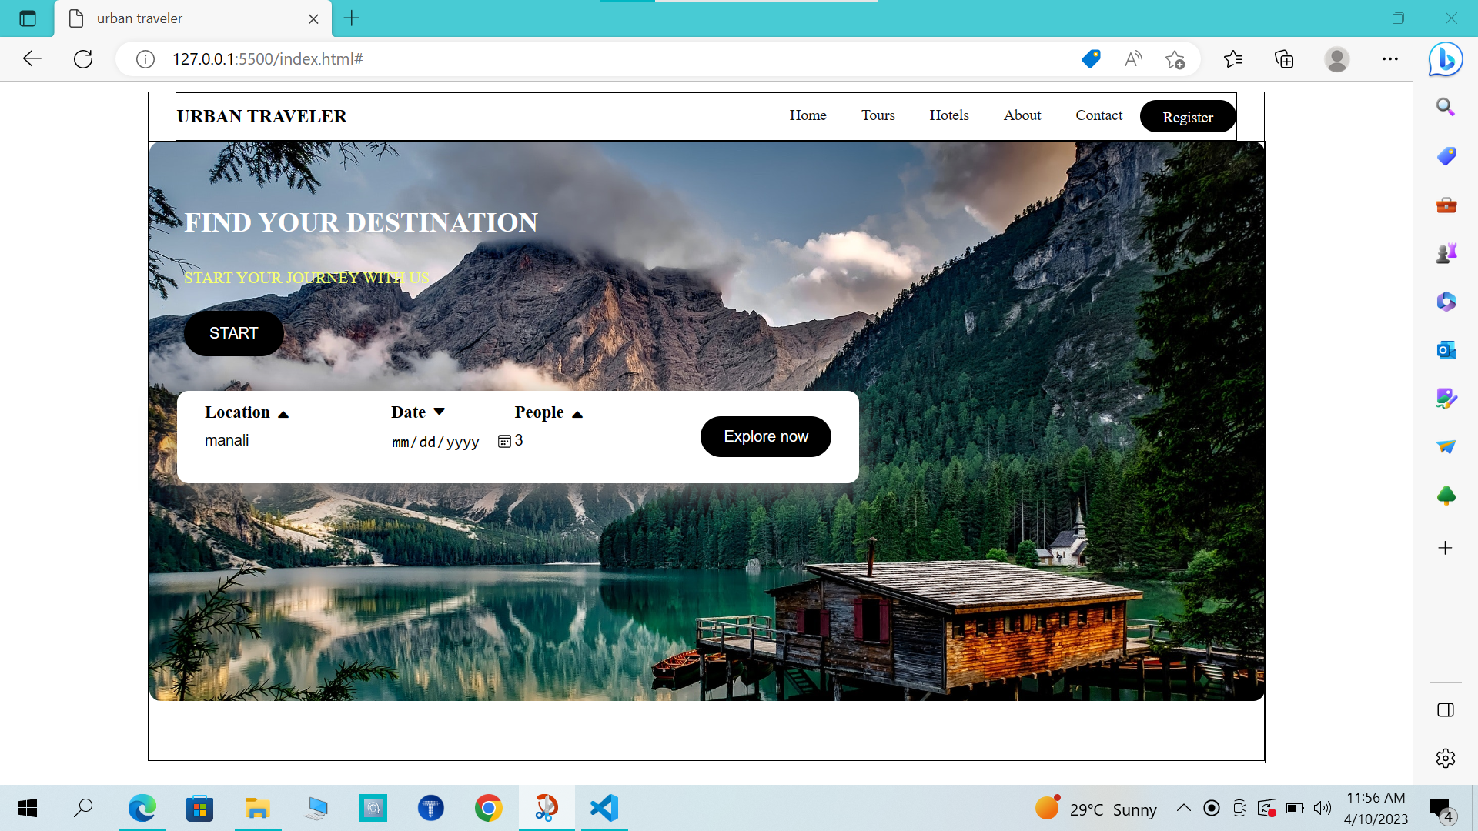

HTML For Travel Box:

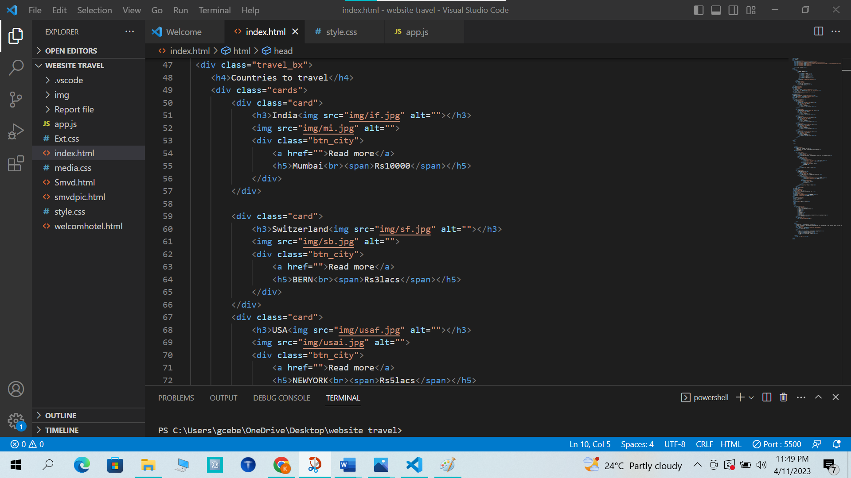

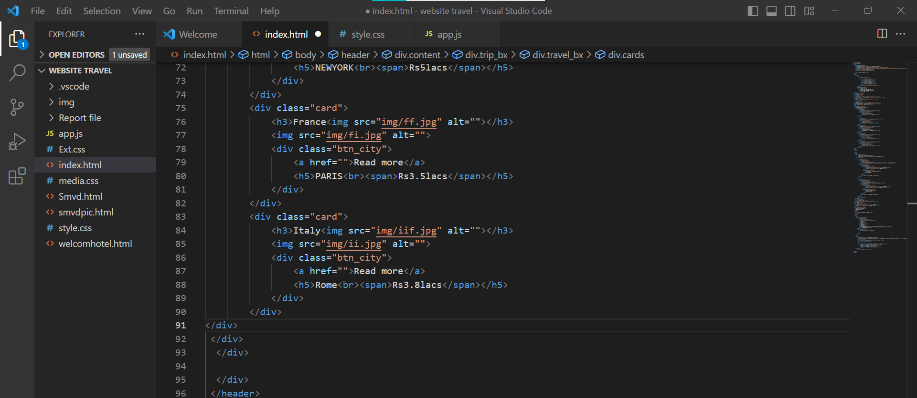

CSS For Travel Box:

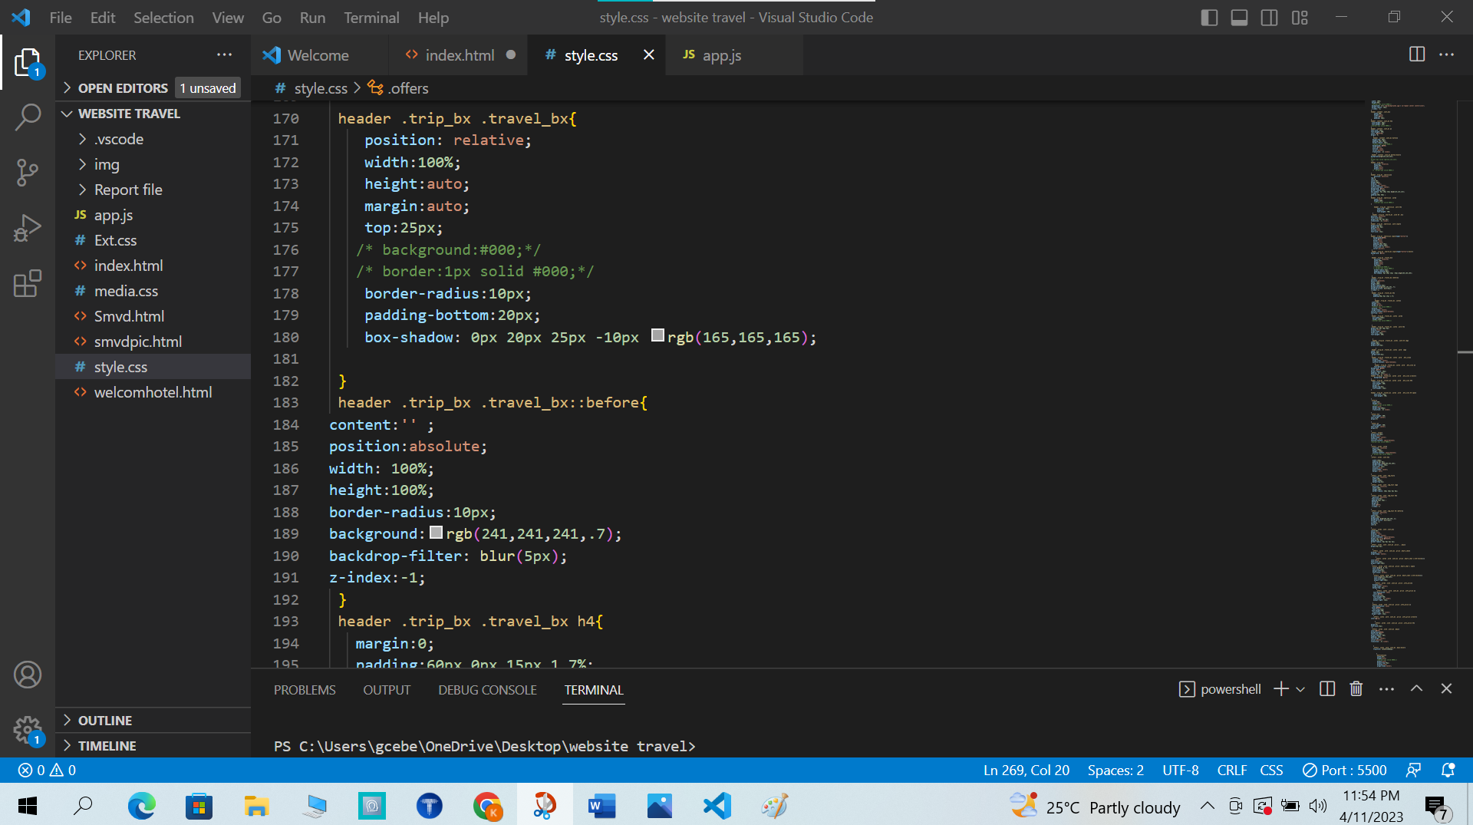

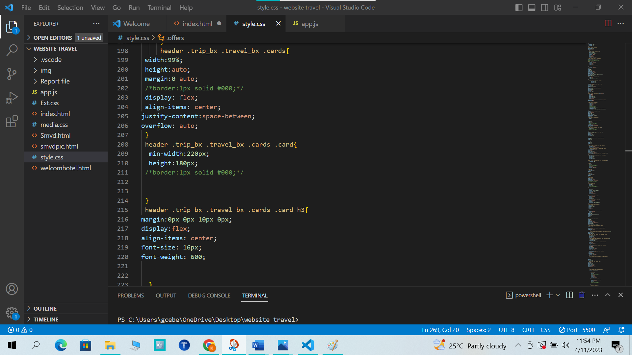

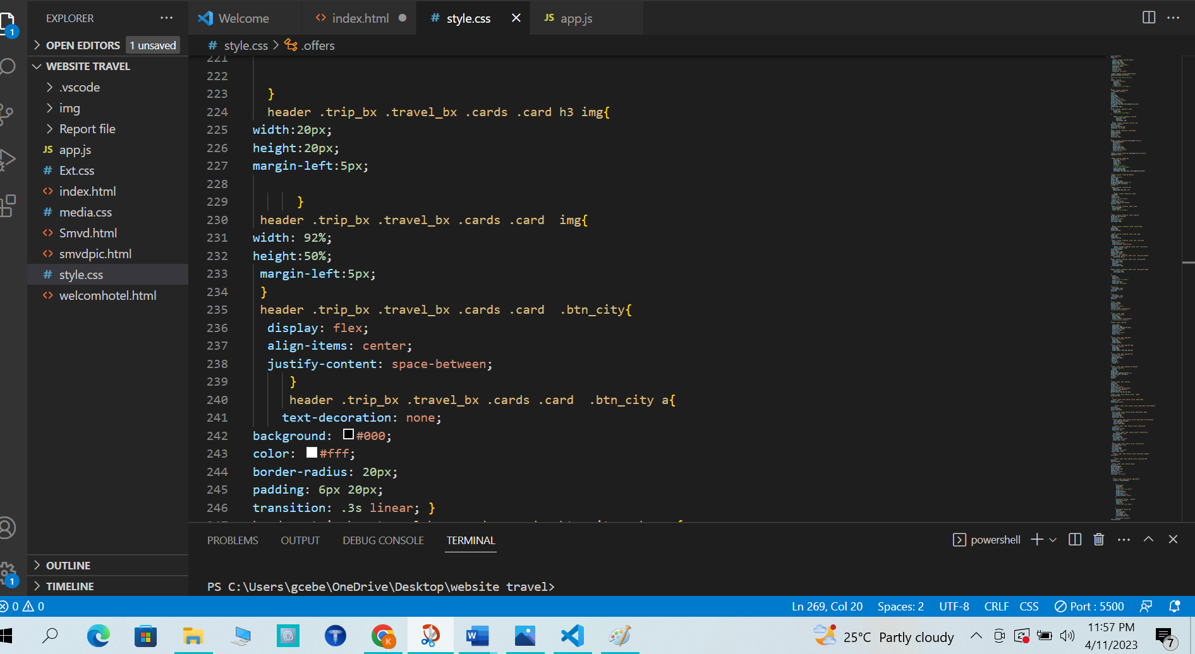

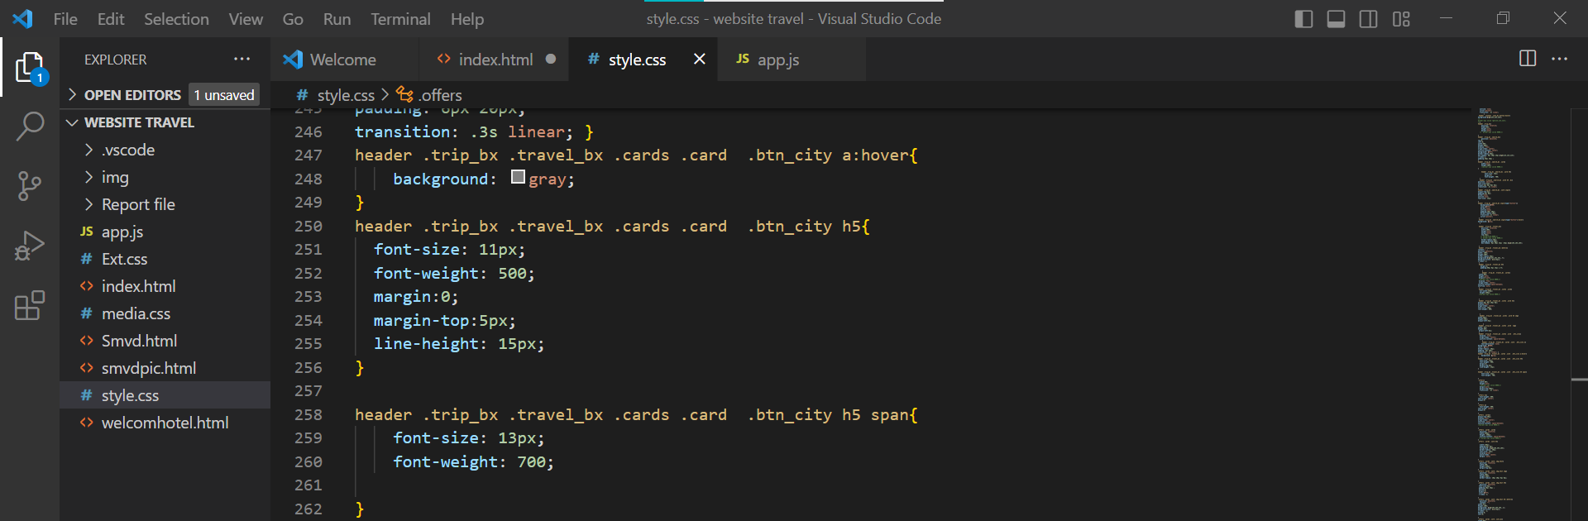

OUTPUT:

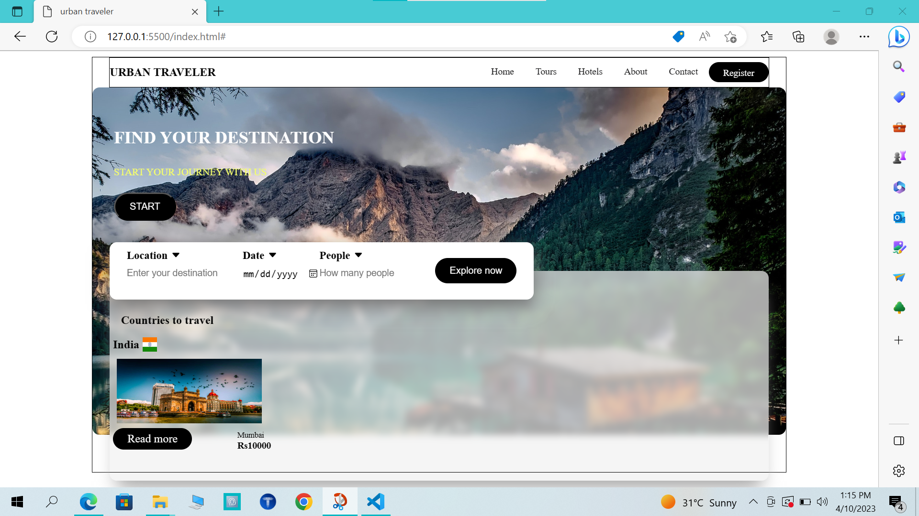

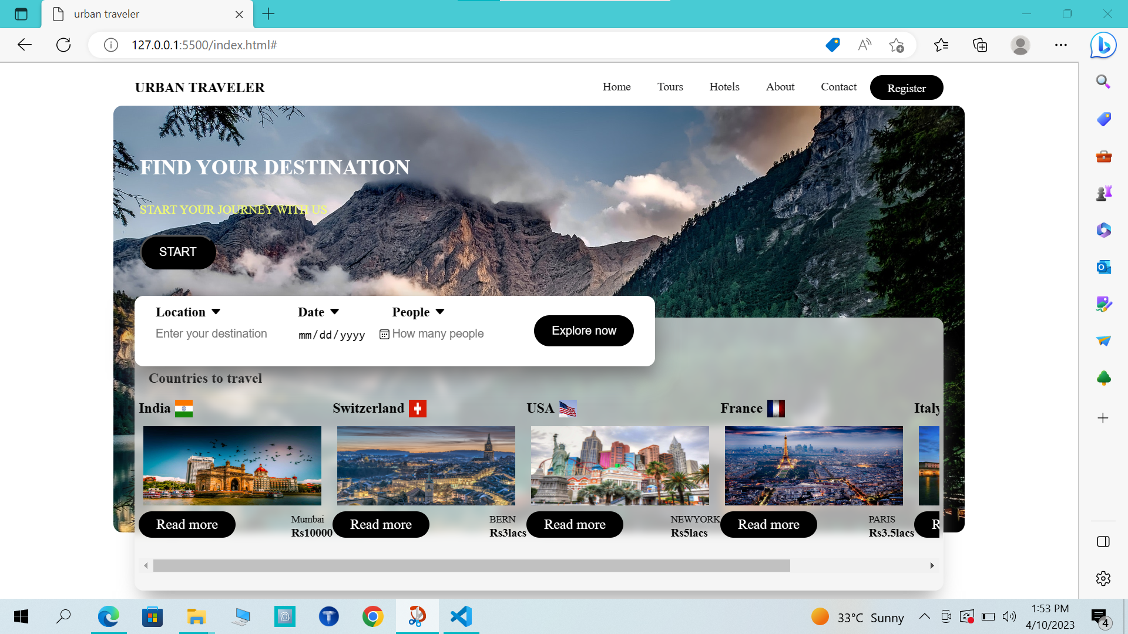

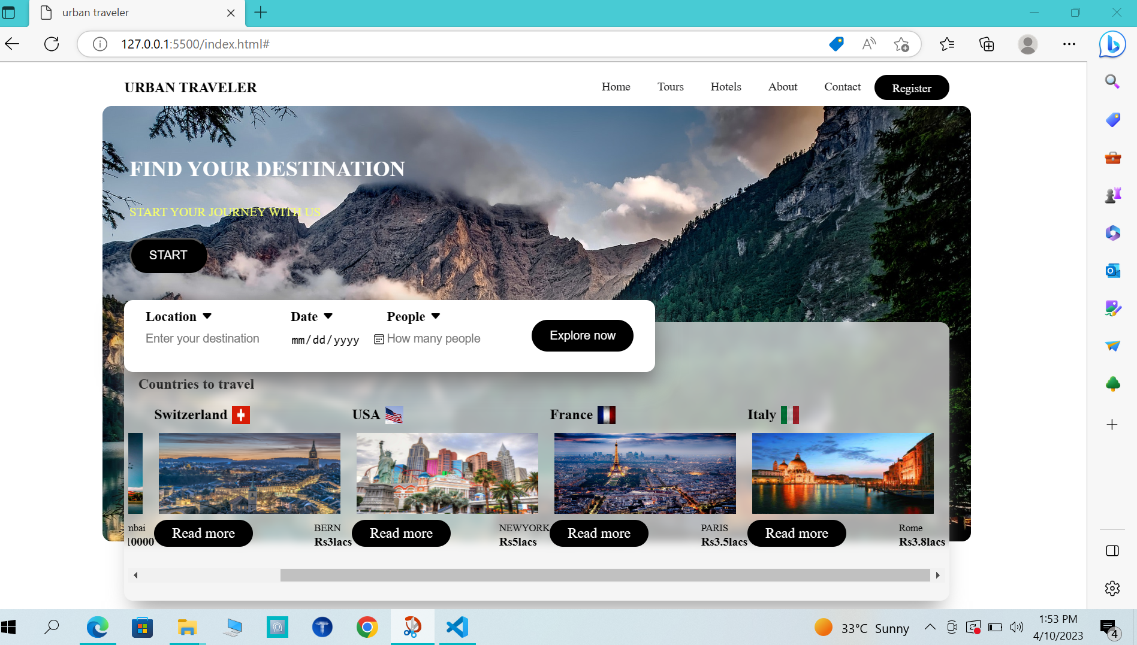

HTML For Offer Box:

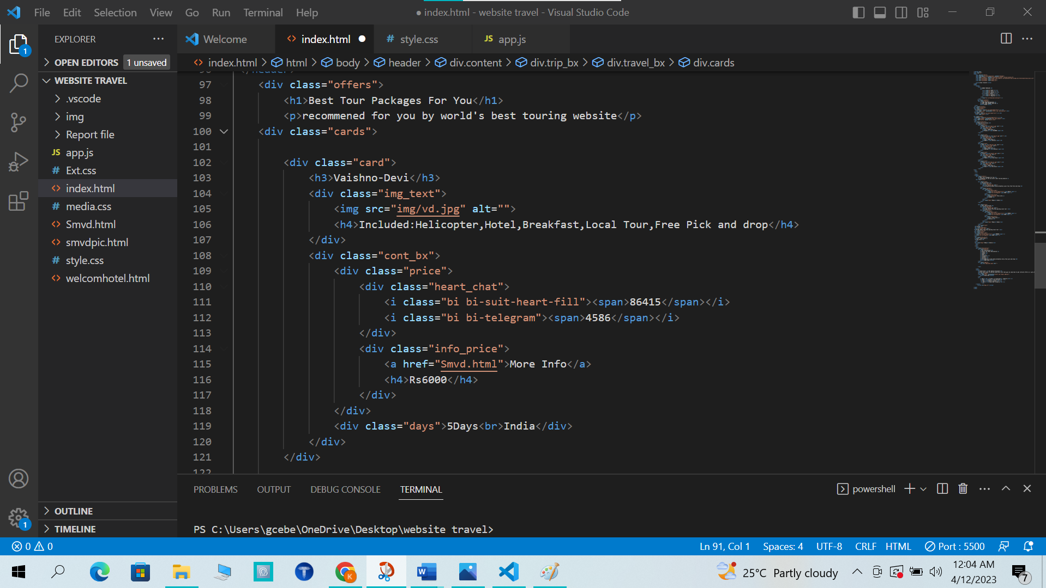

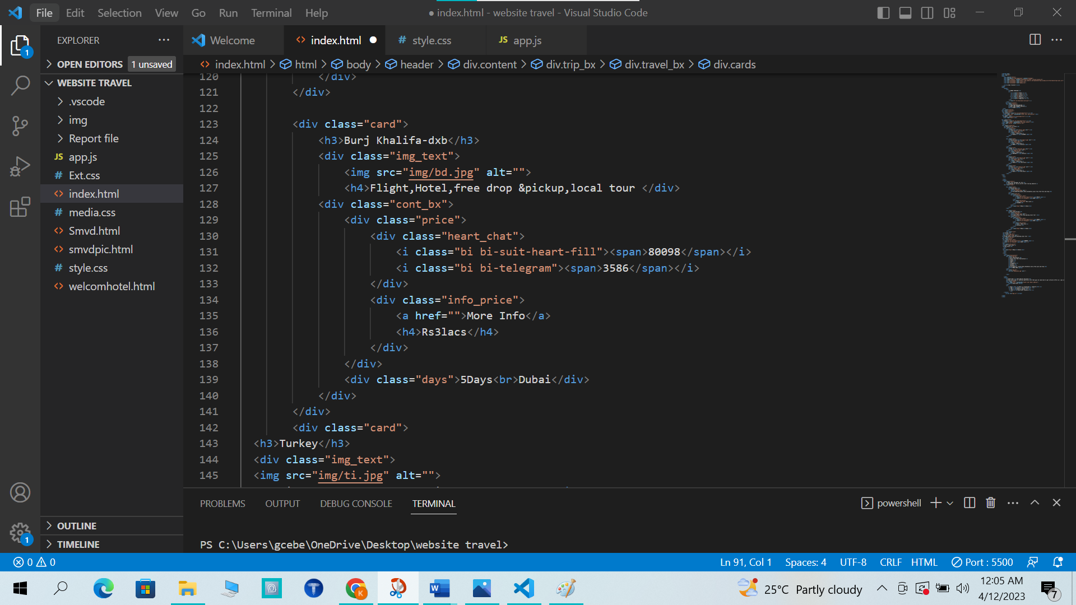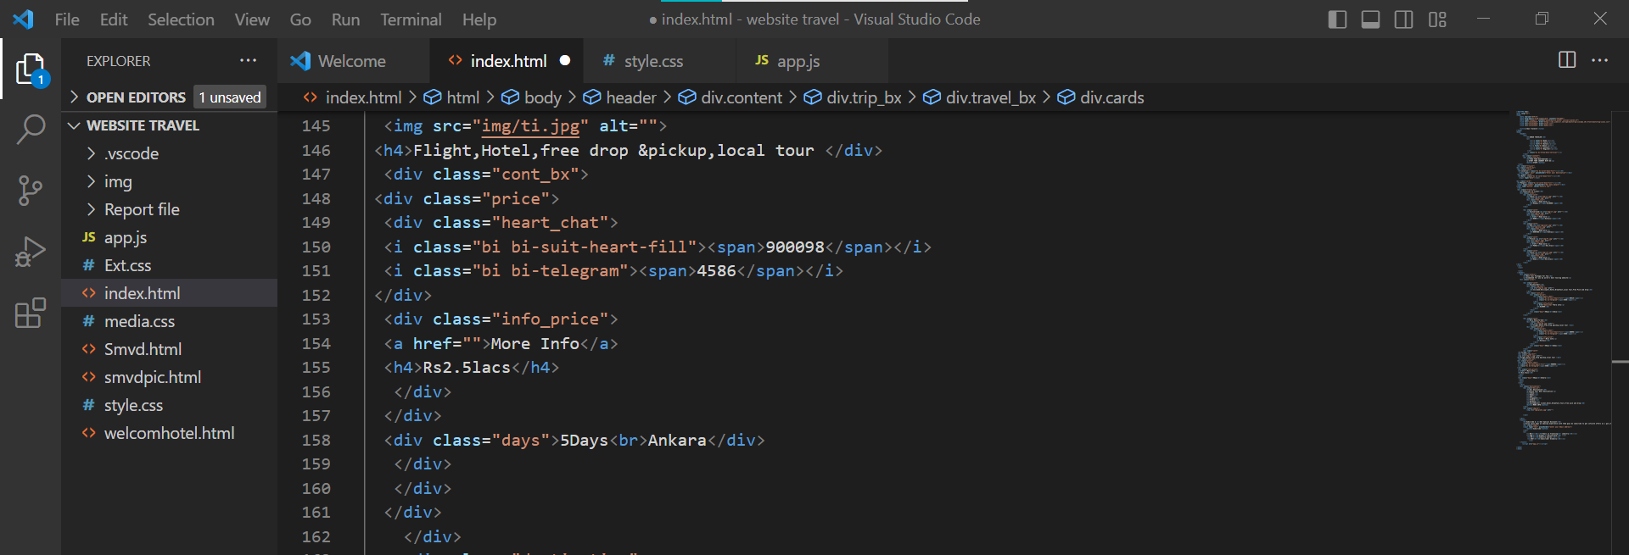

CSS For Offer Box:

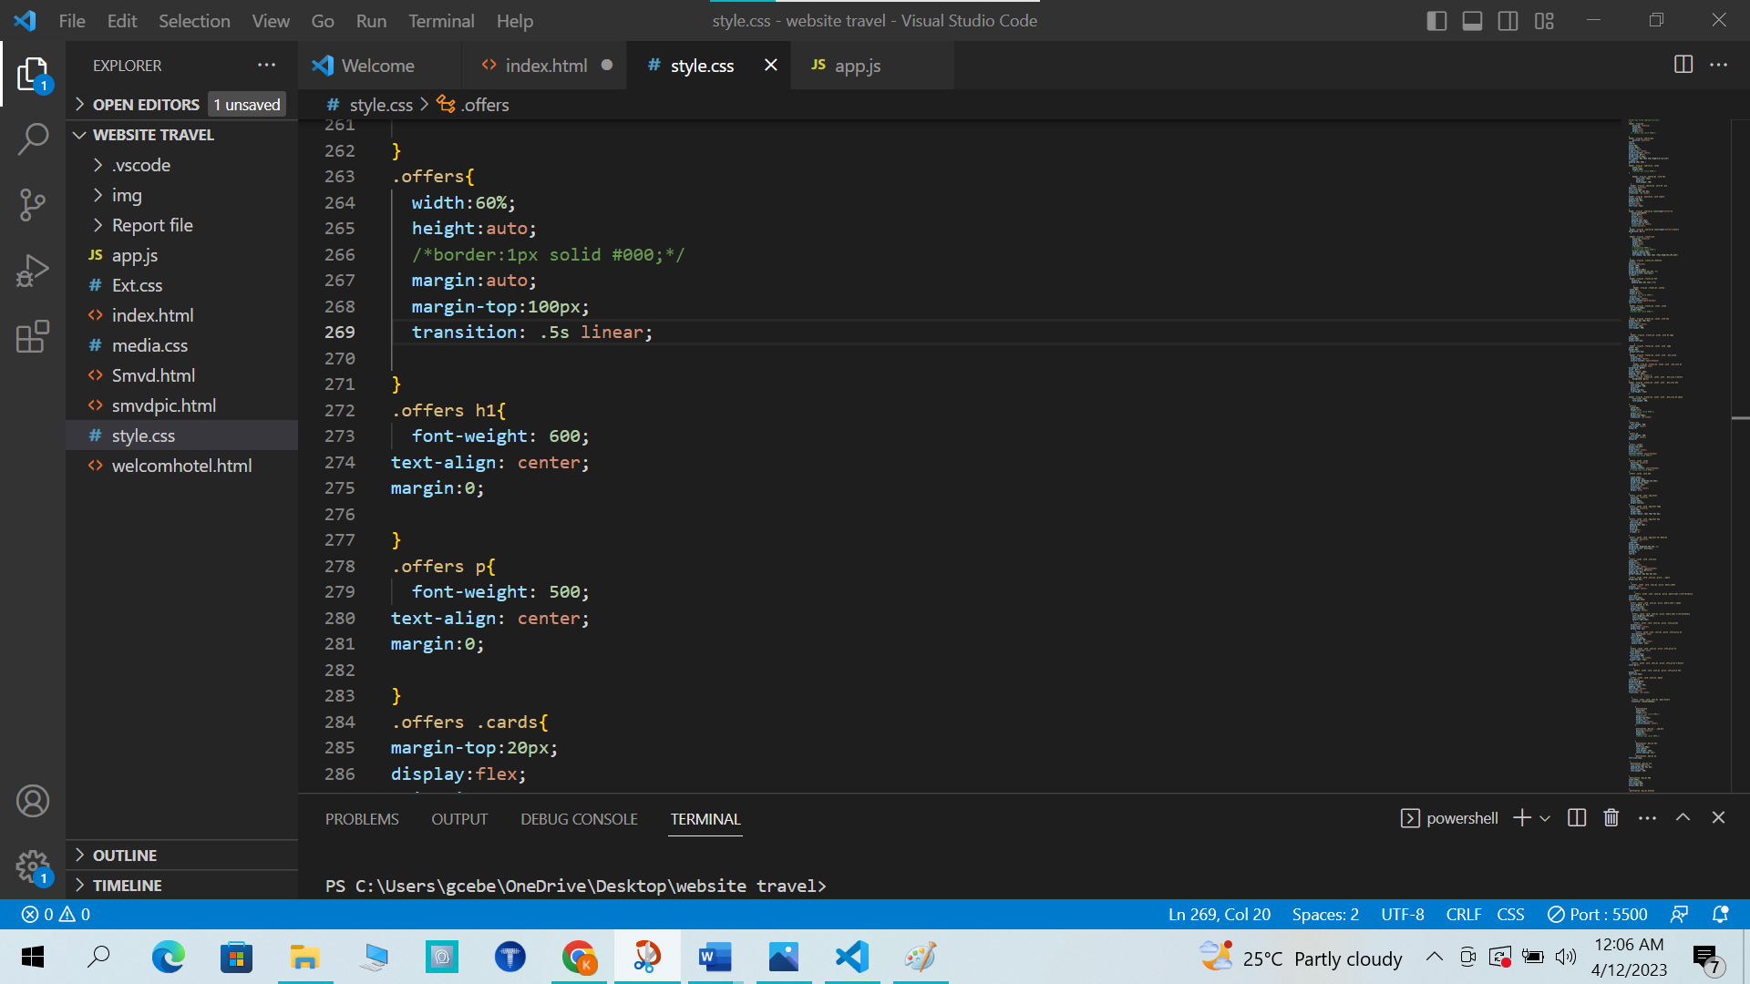

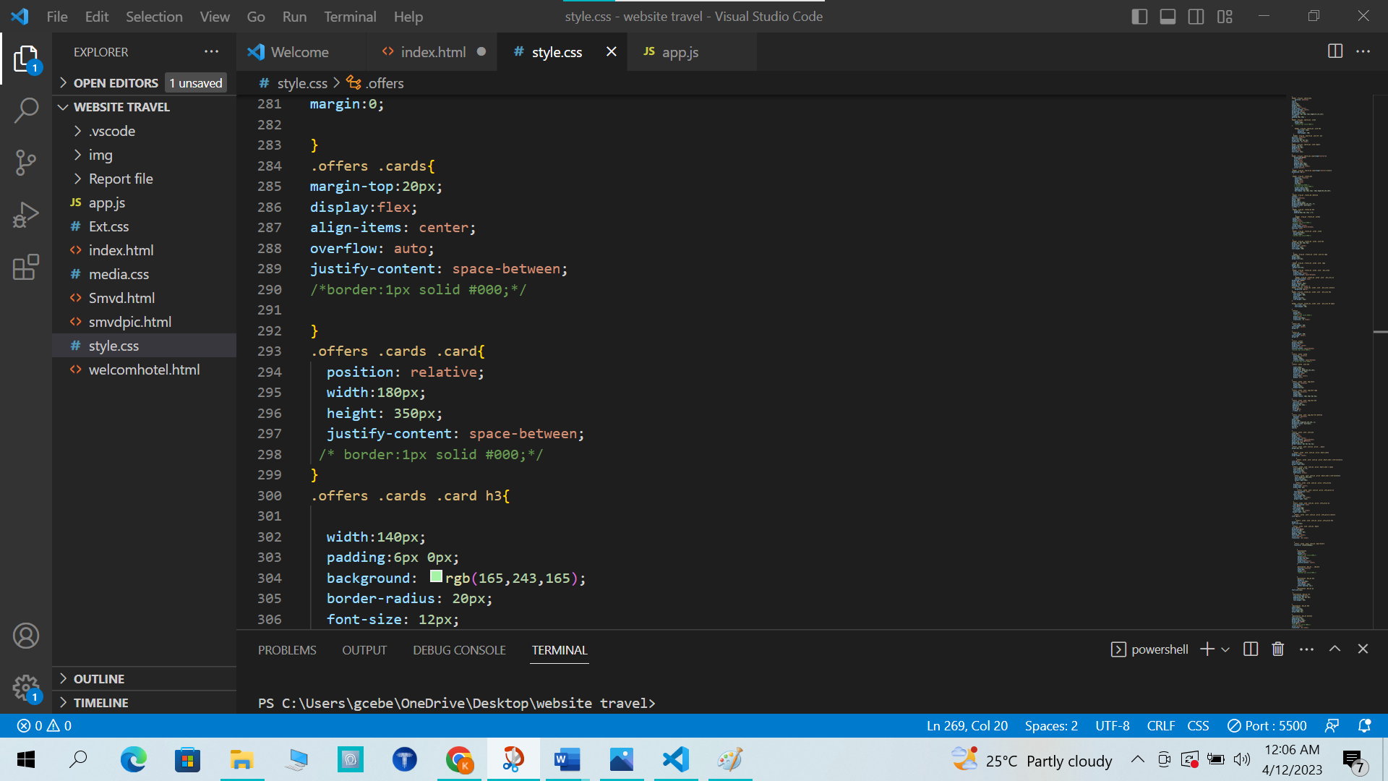

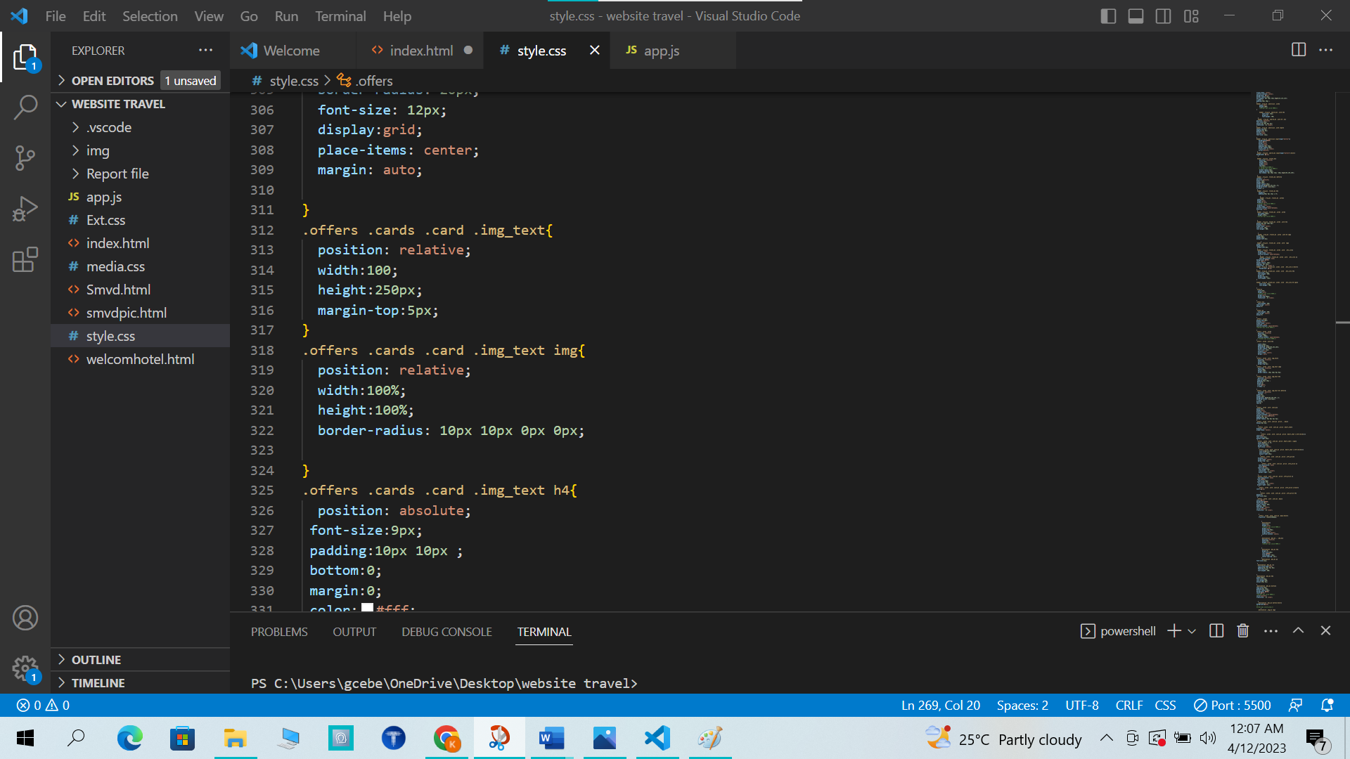

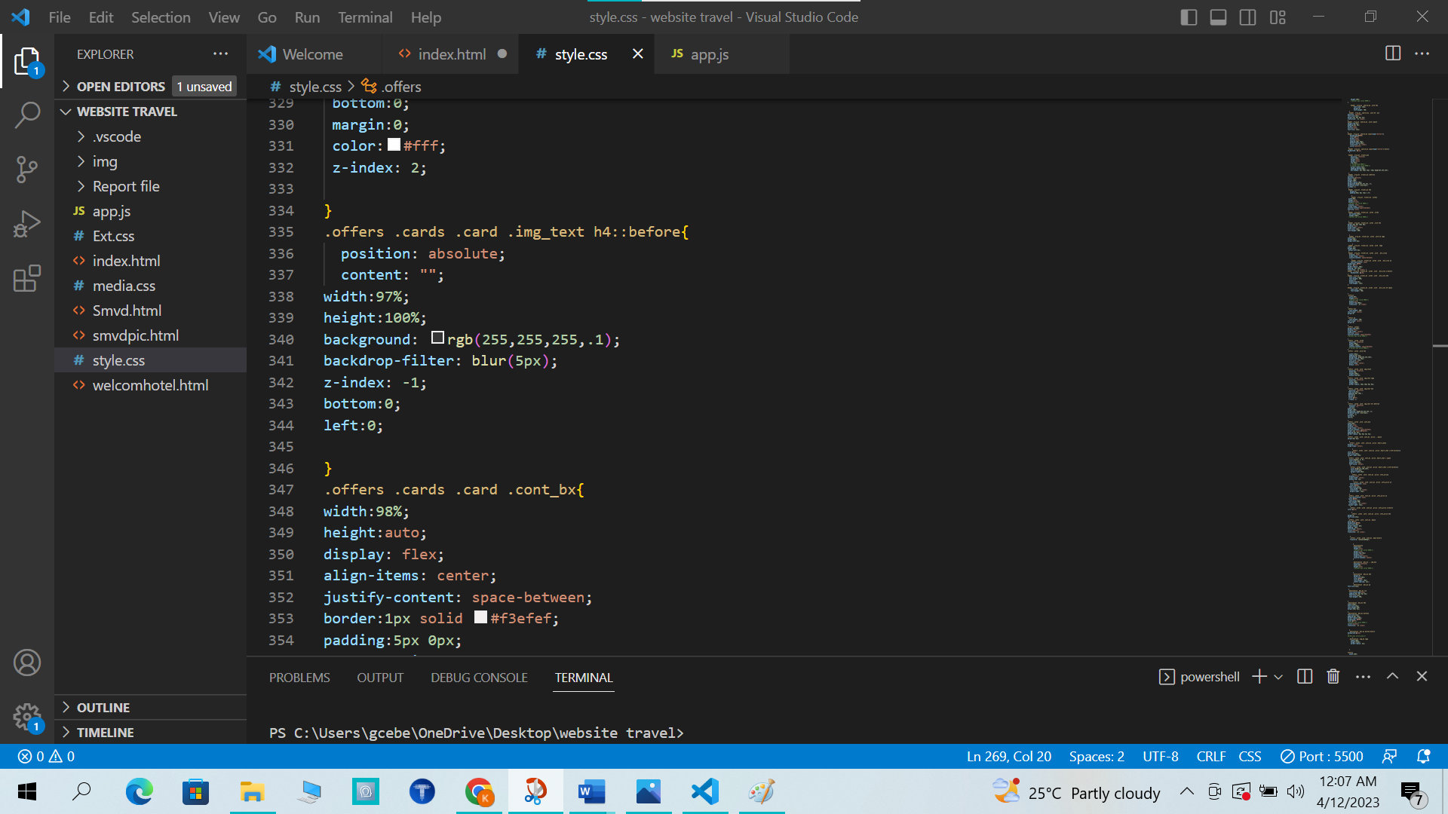

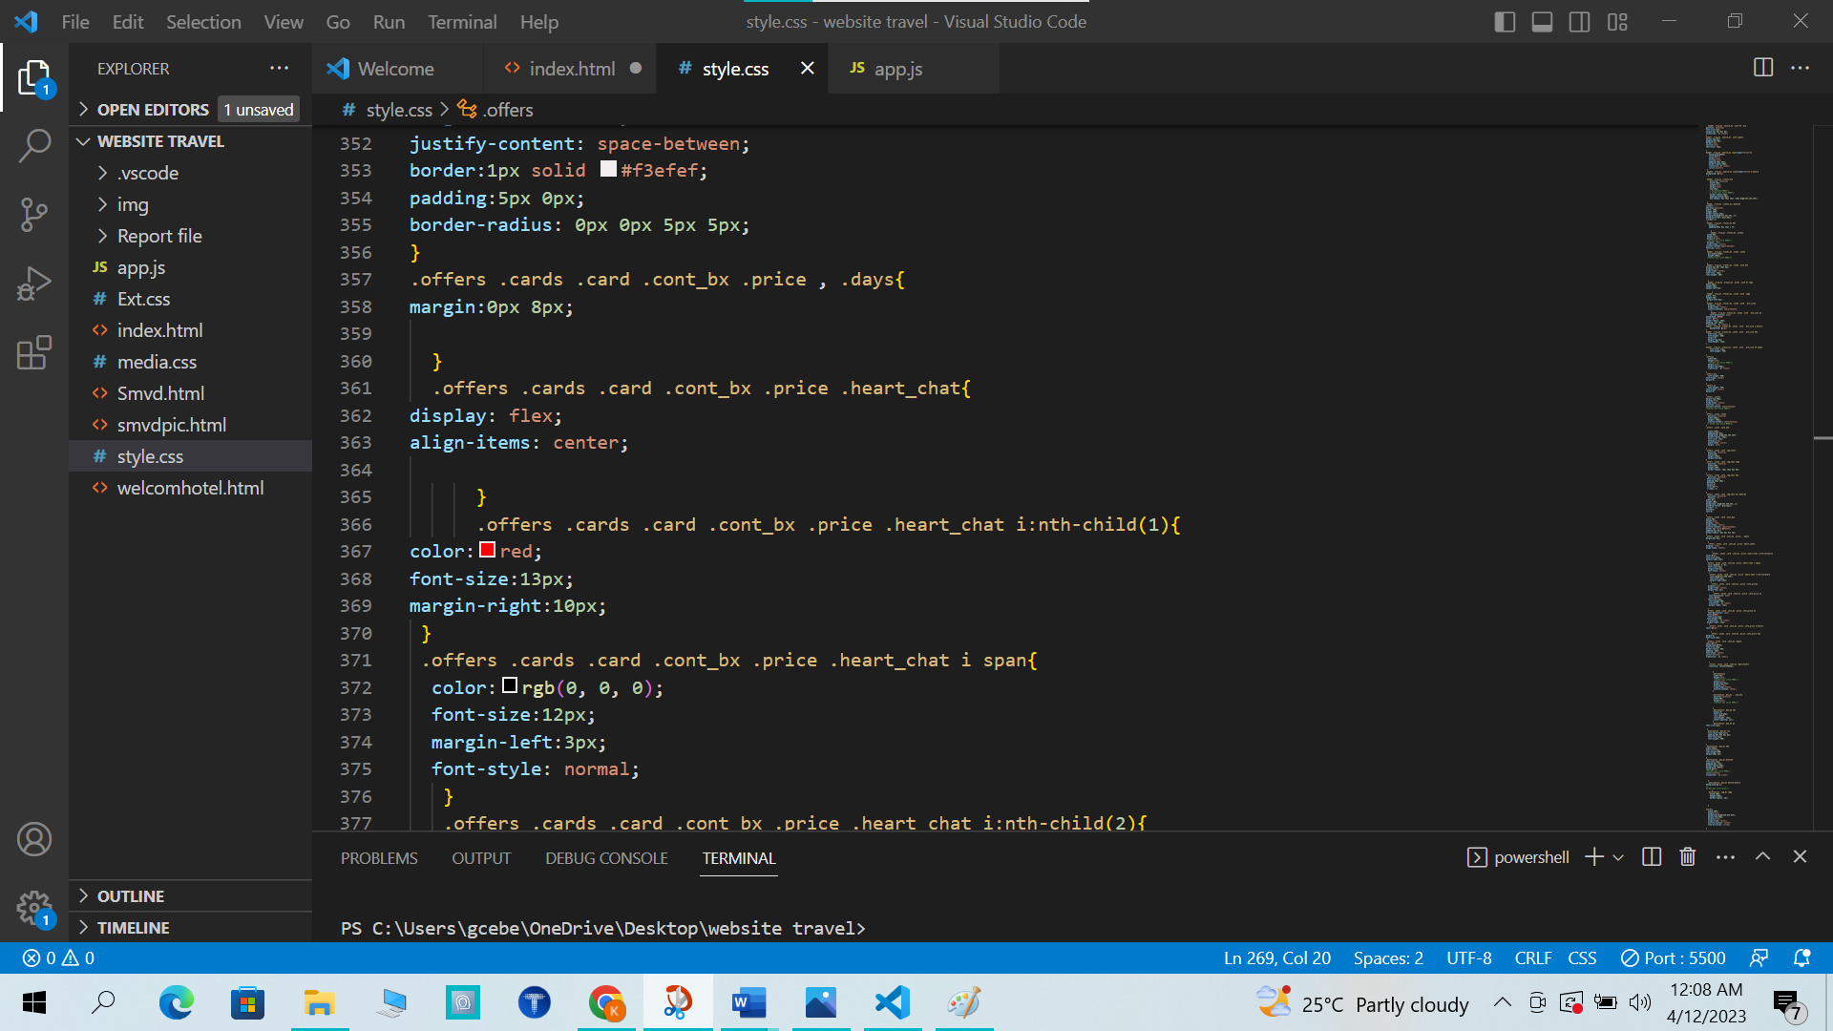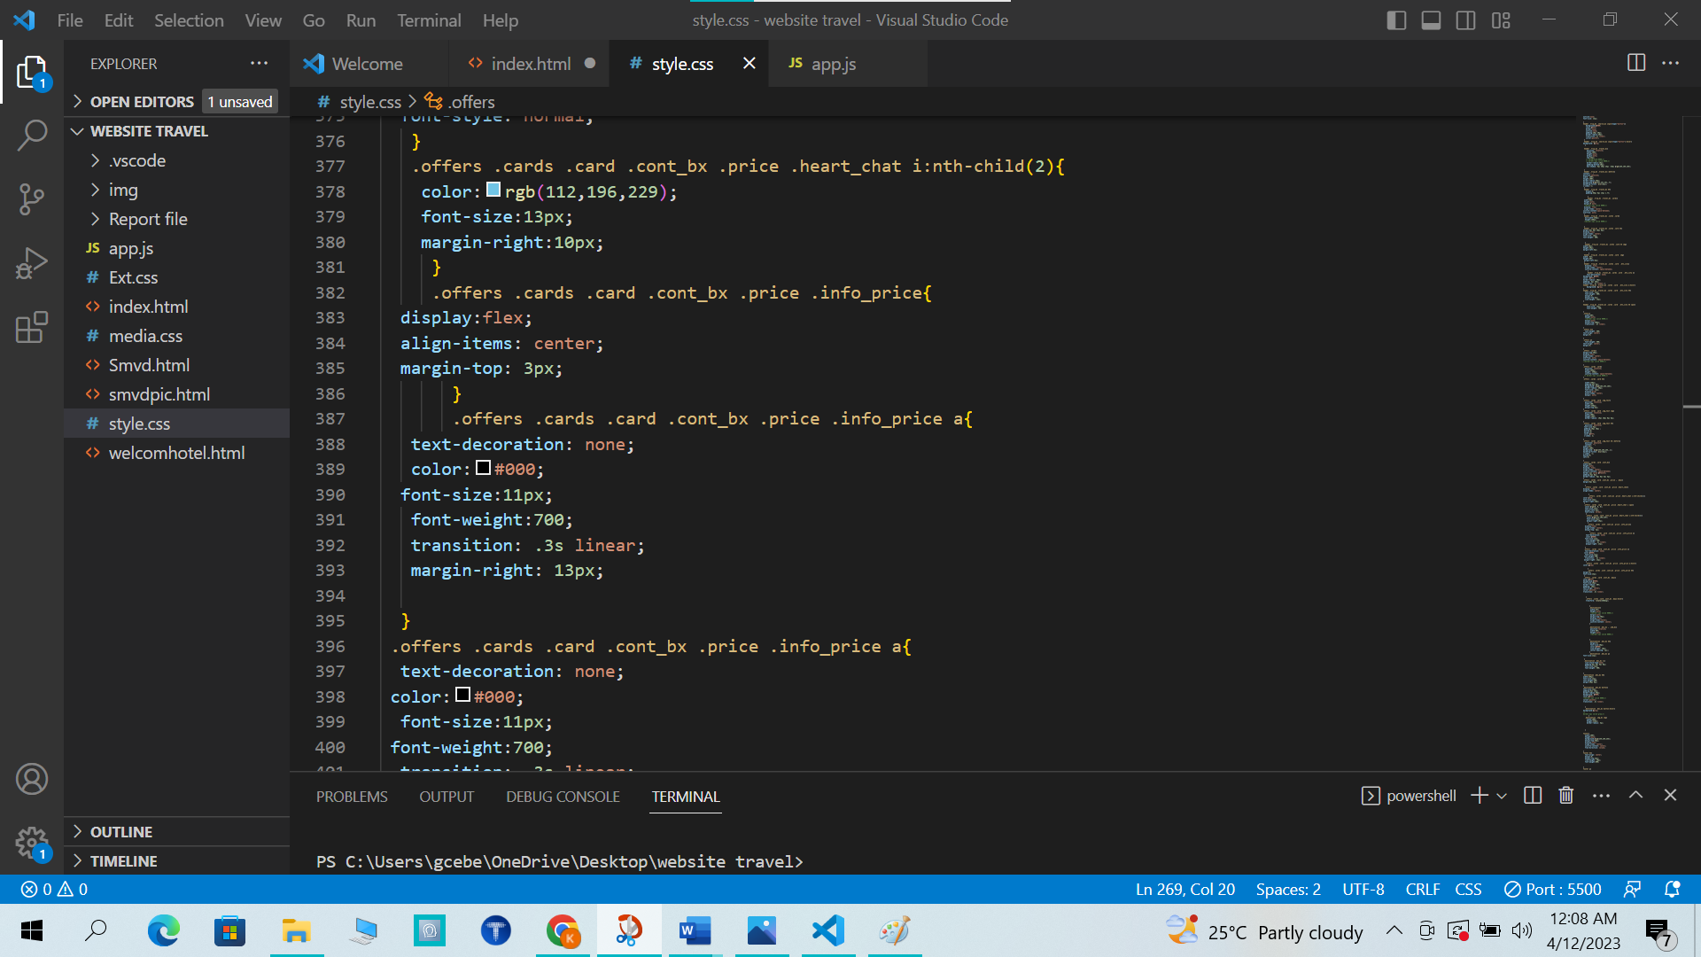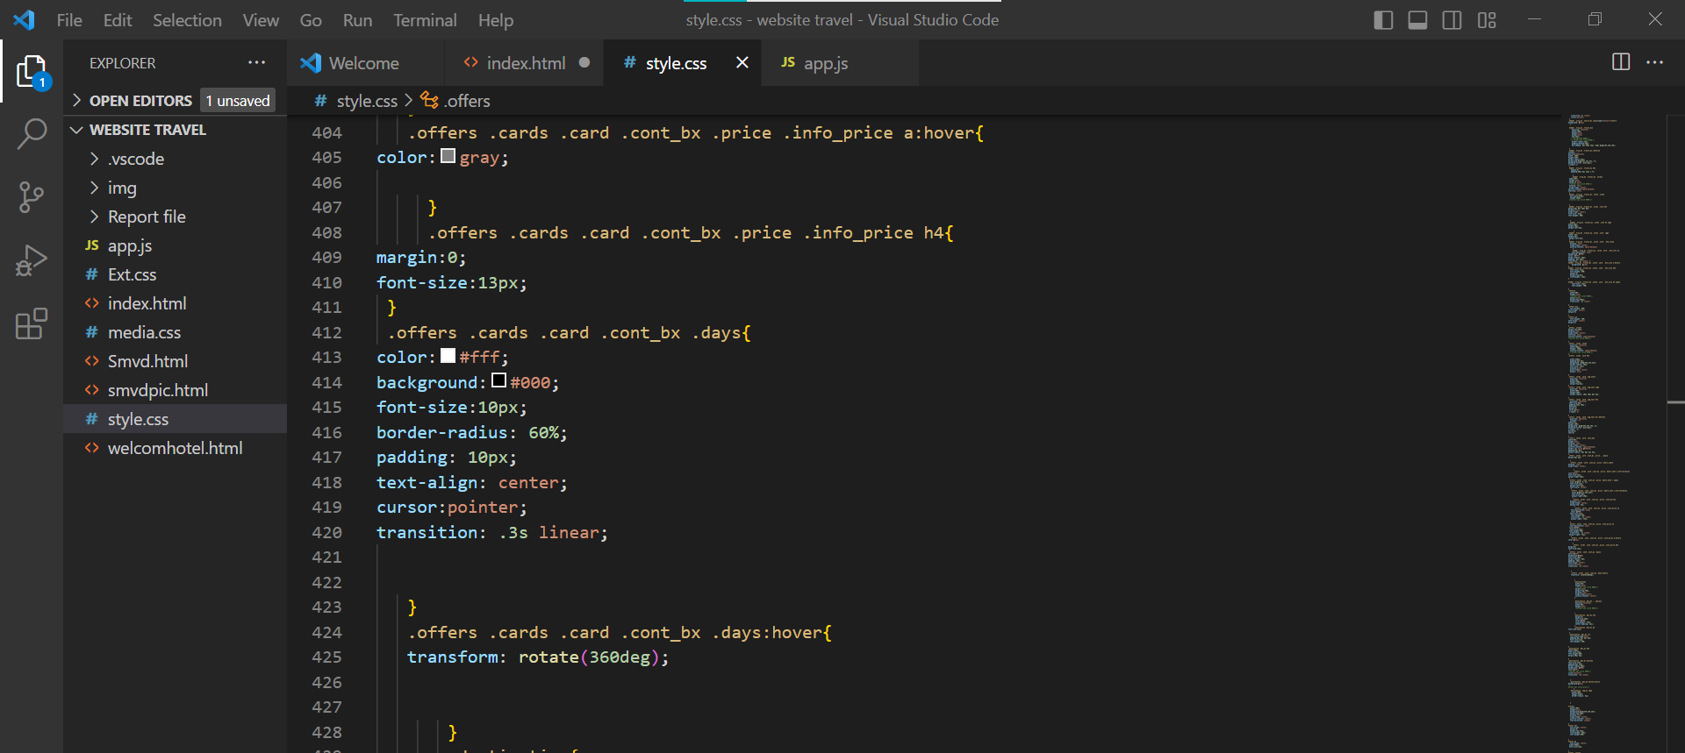

OUTPUT OFFER BOX:

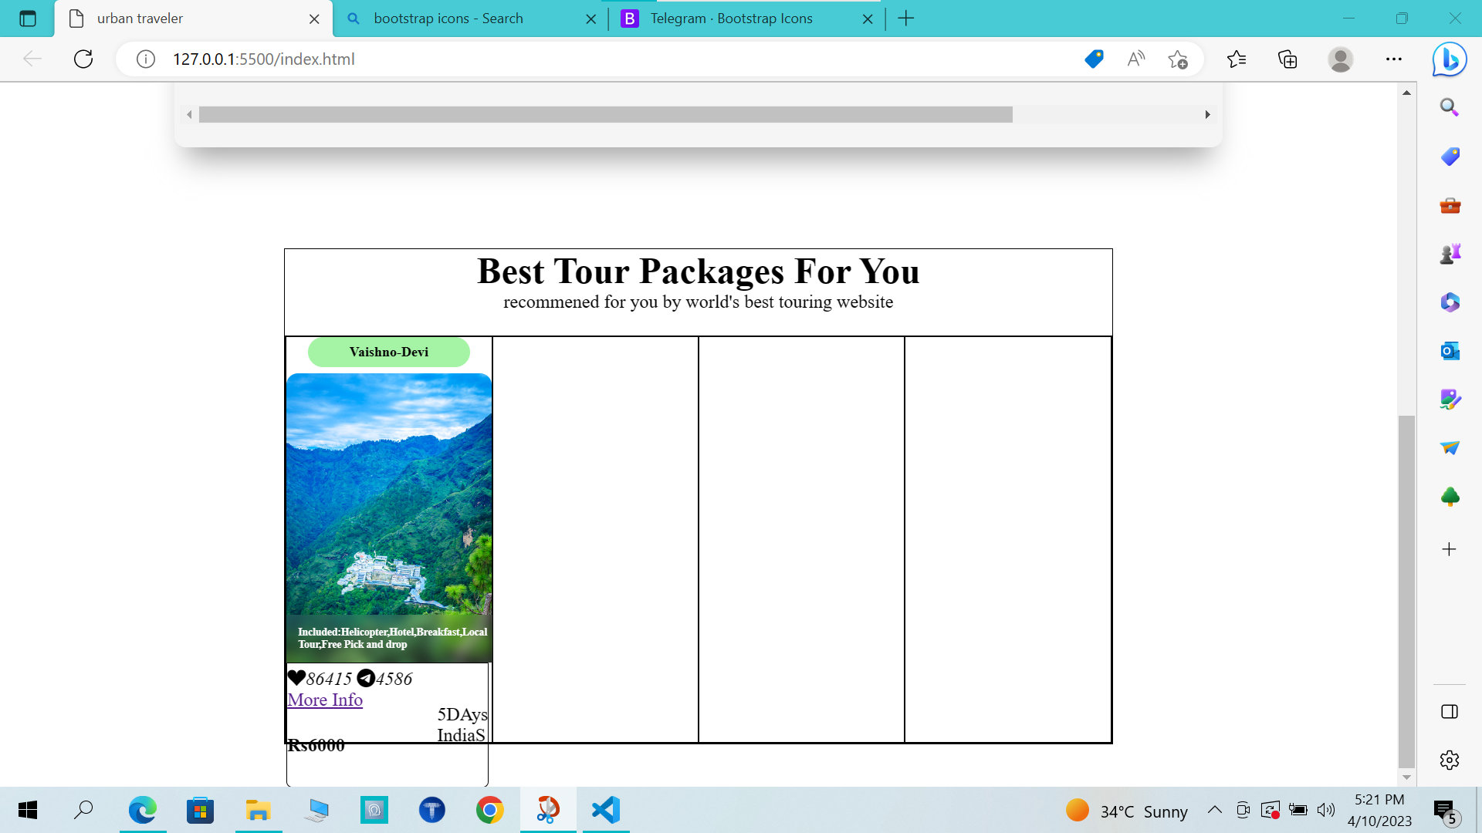

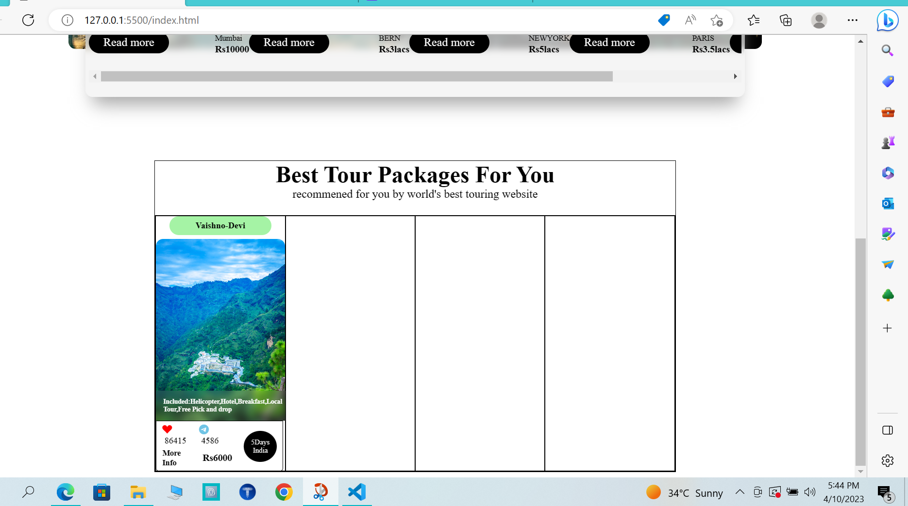

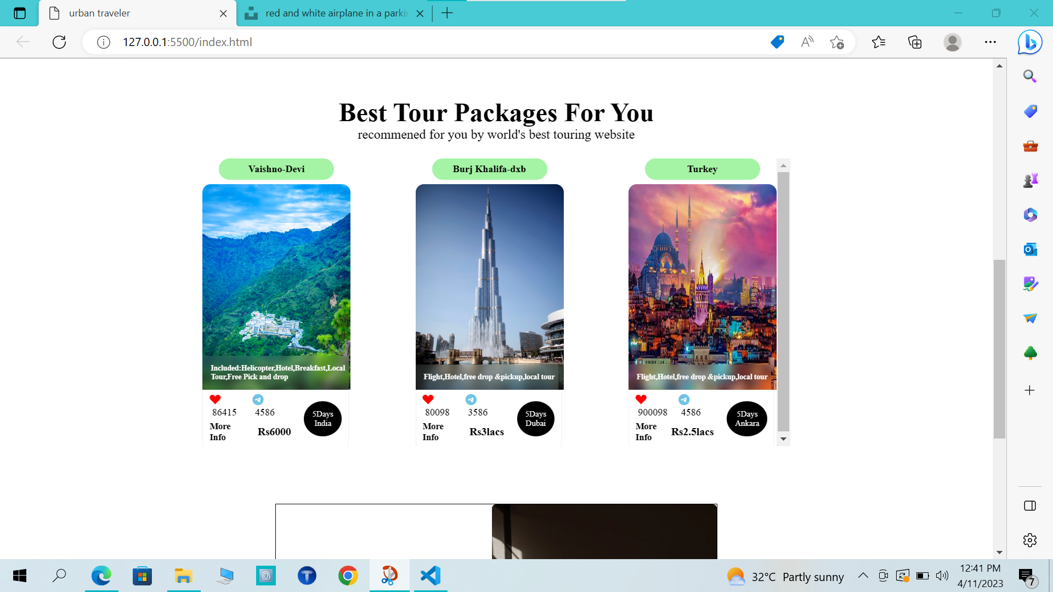

HTML FOR MORE INFO VAISHNO DEVI:

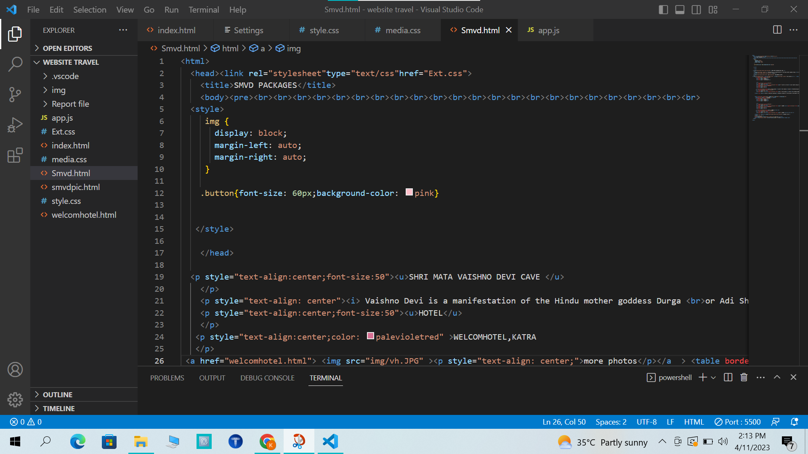

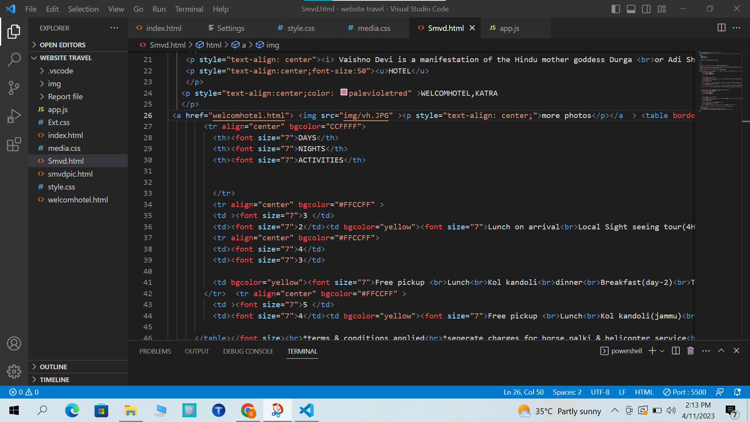

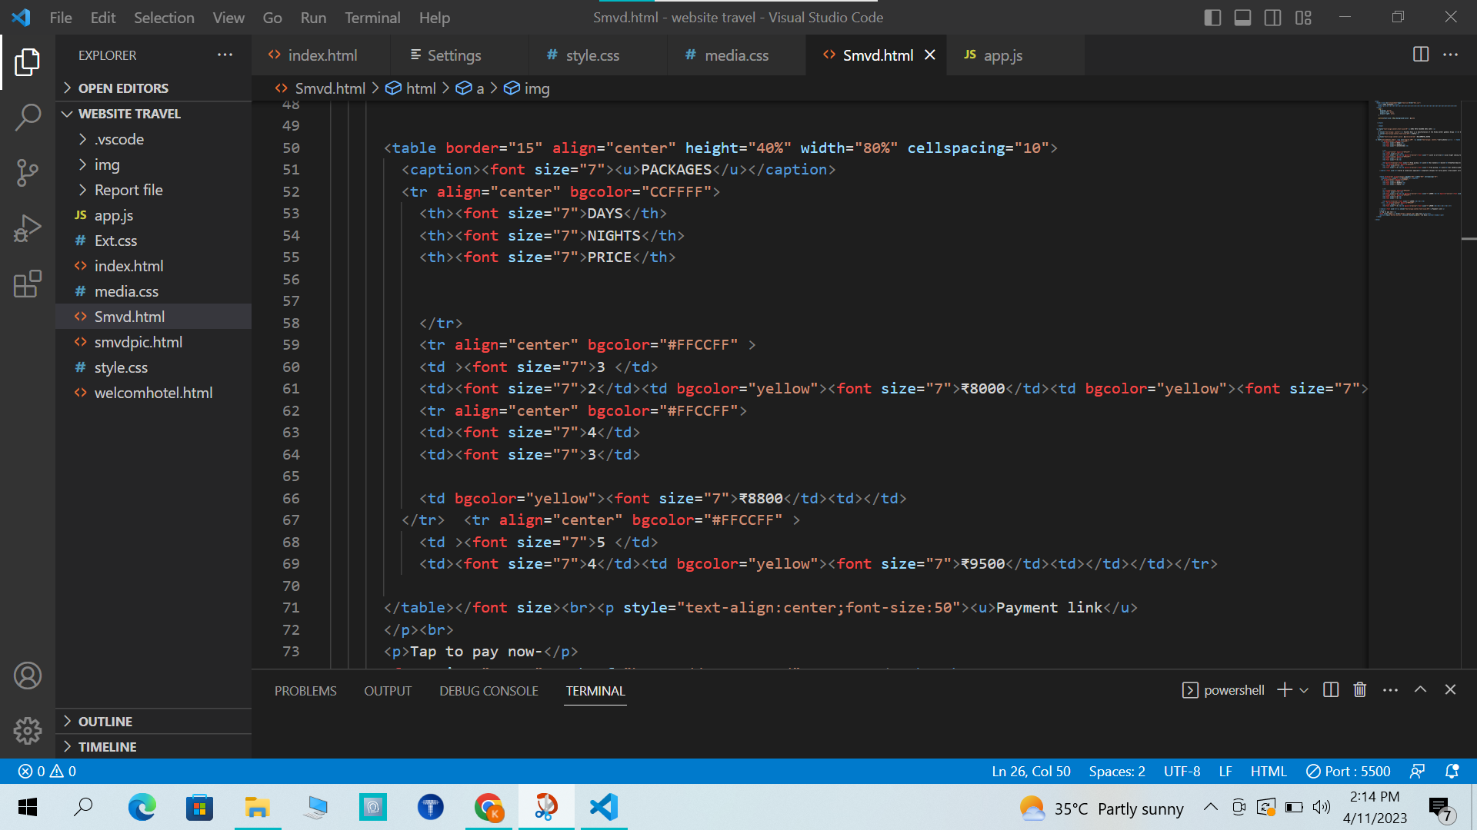

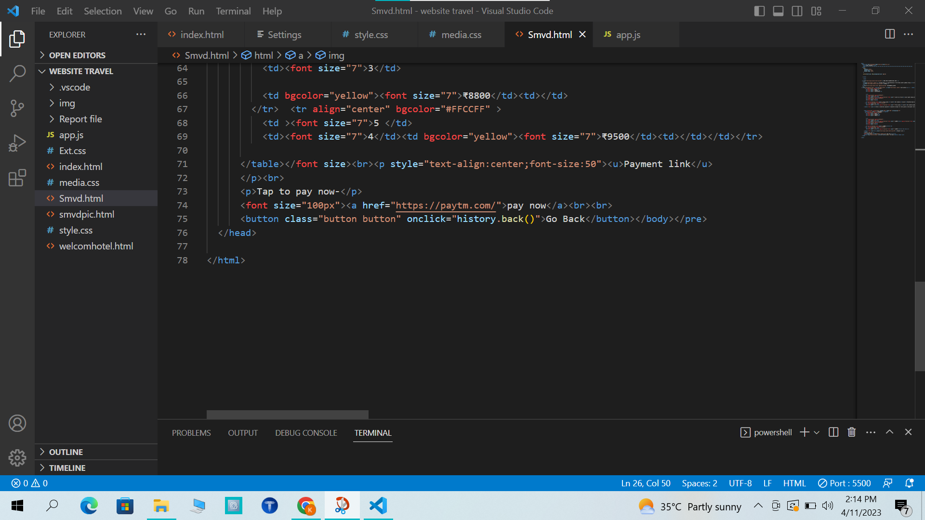

OUTPUT FOR MORE INFO VAISHNO DEVI:

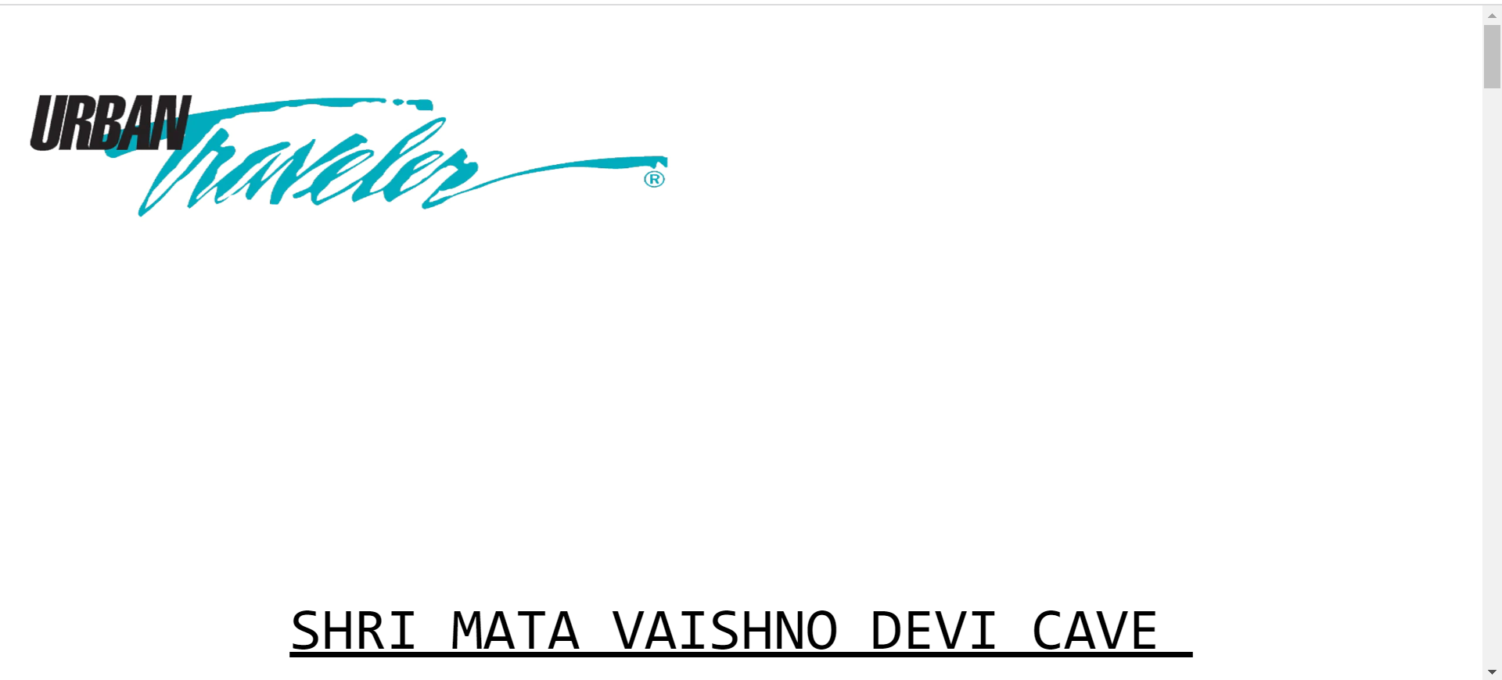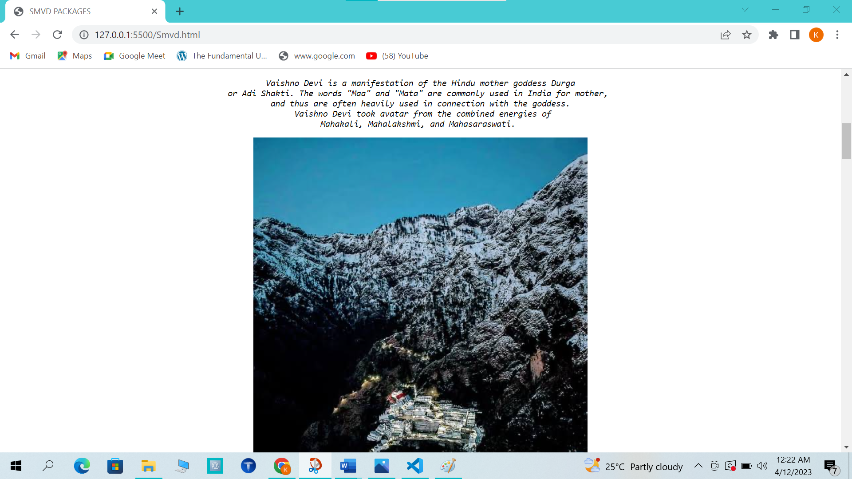

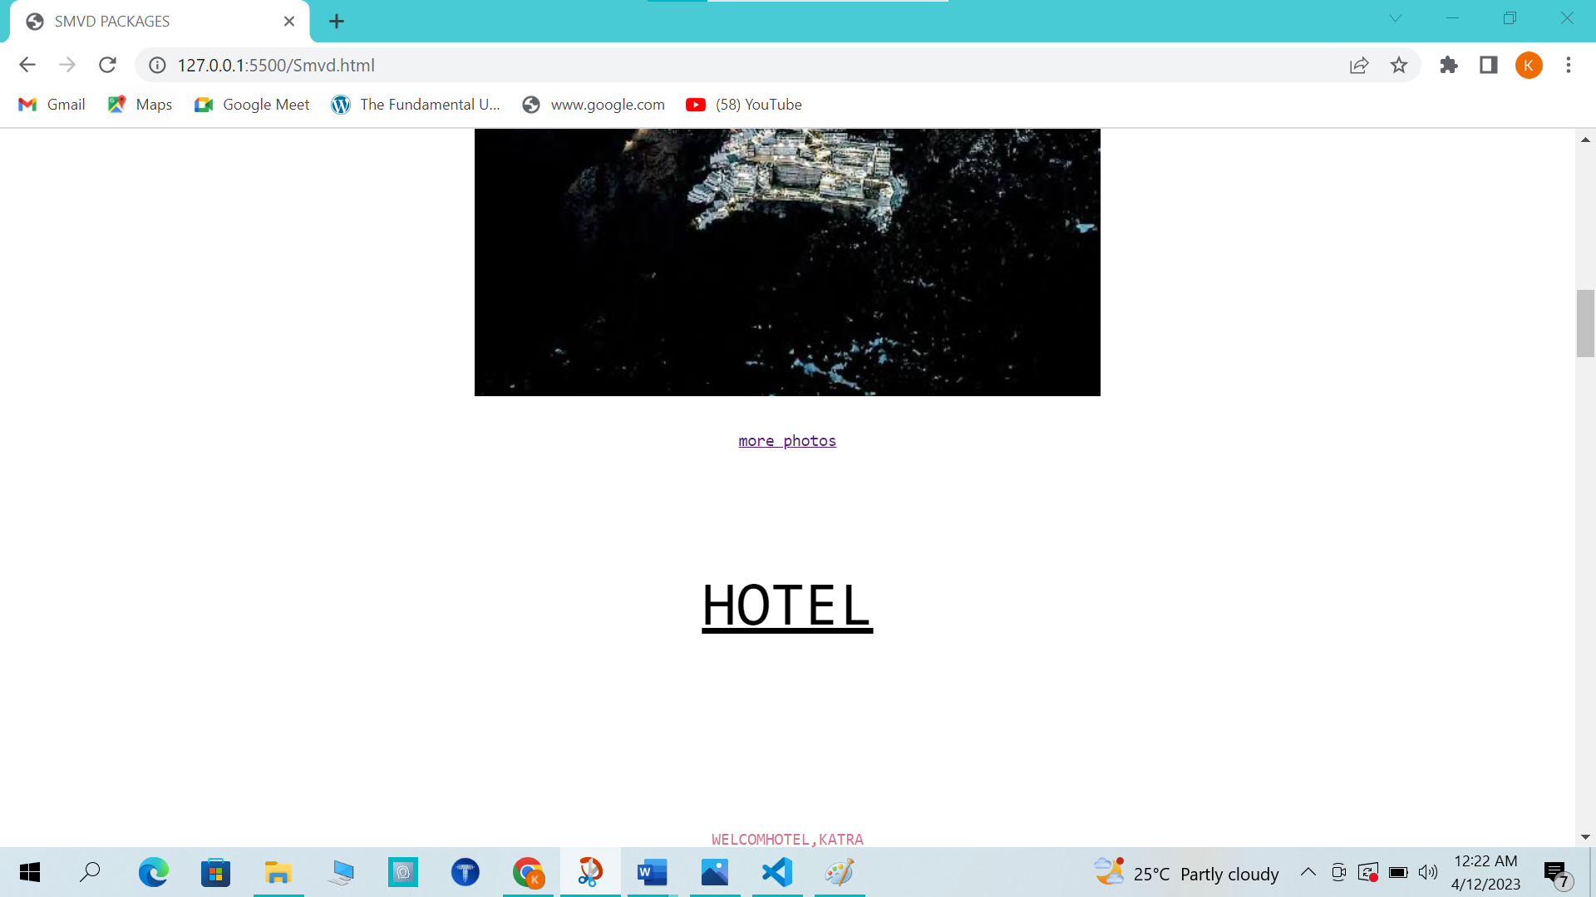

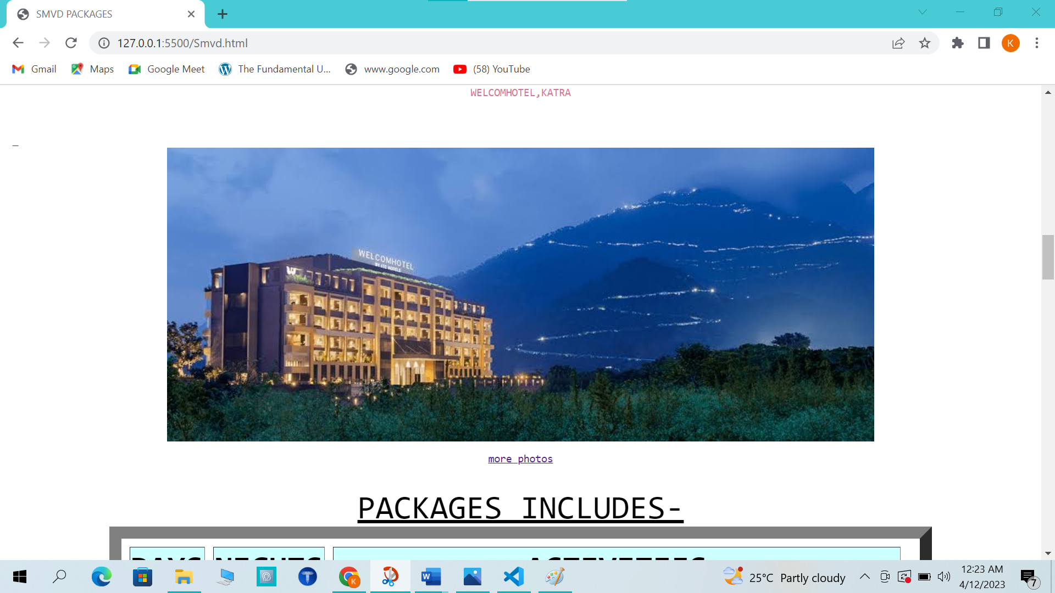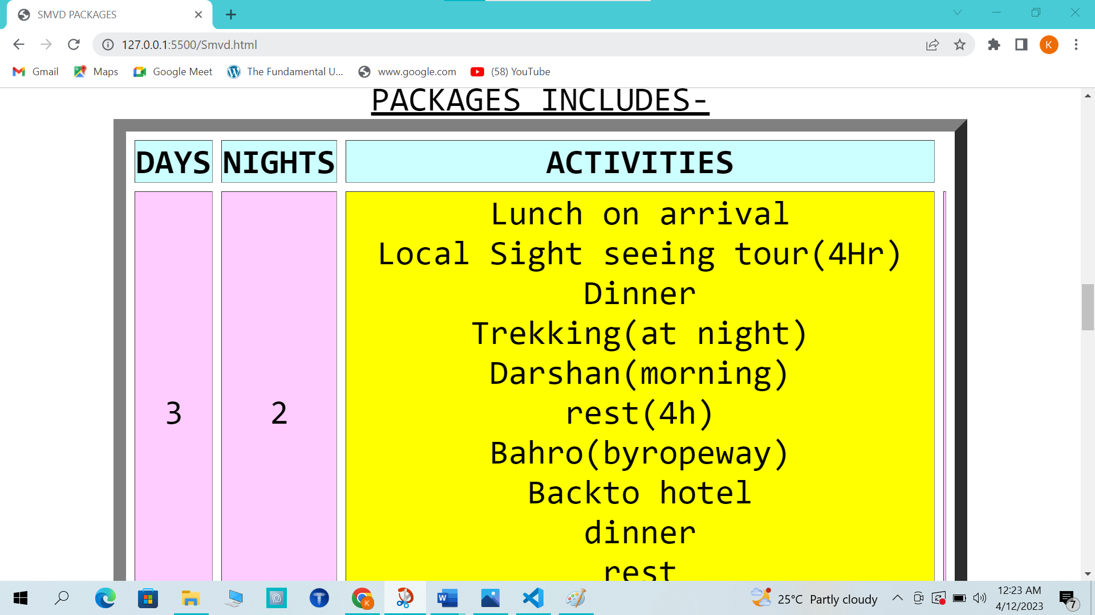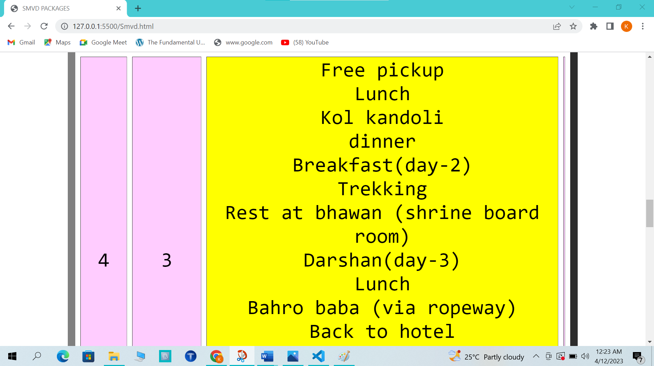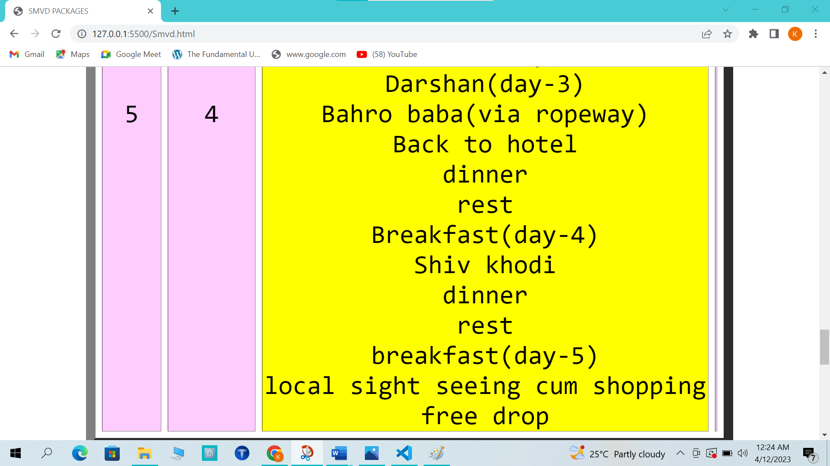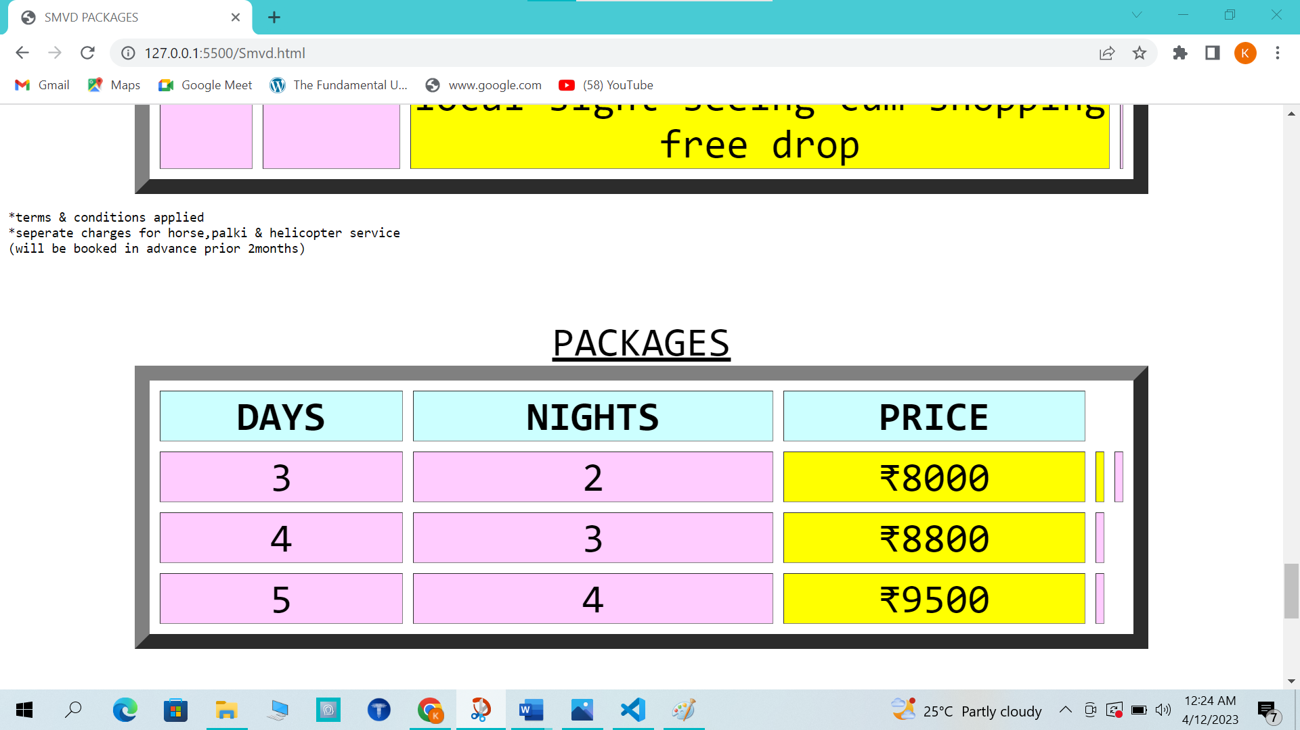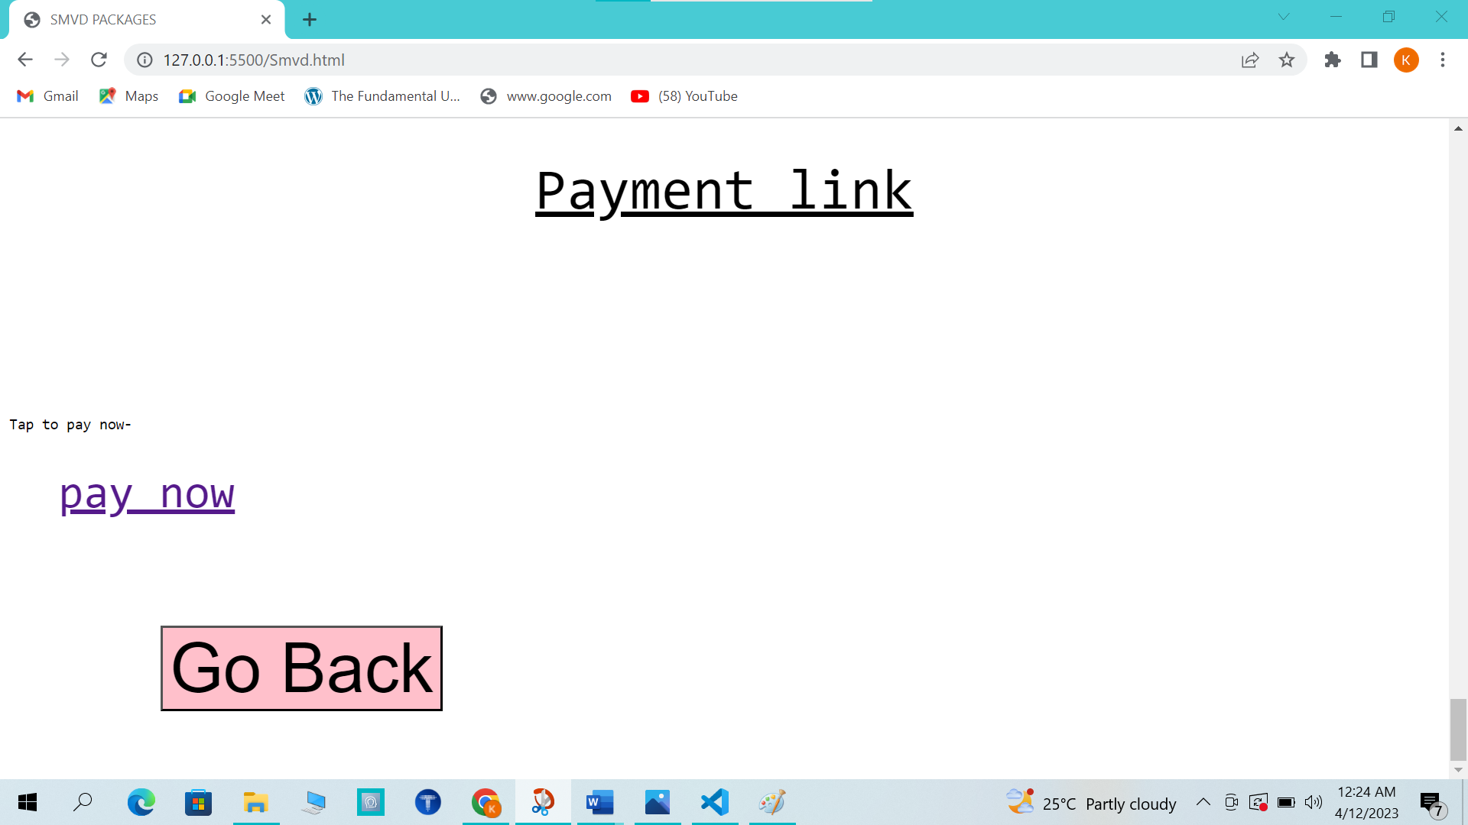

HTML FOR DESTINATION BOX:

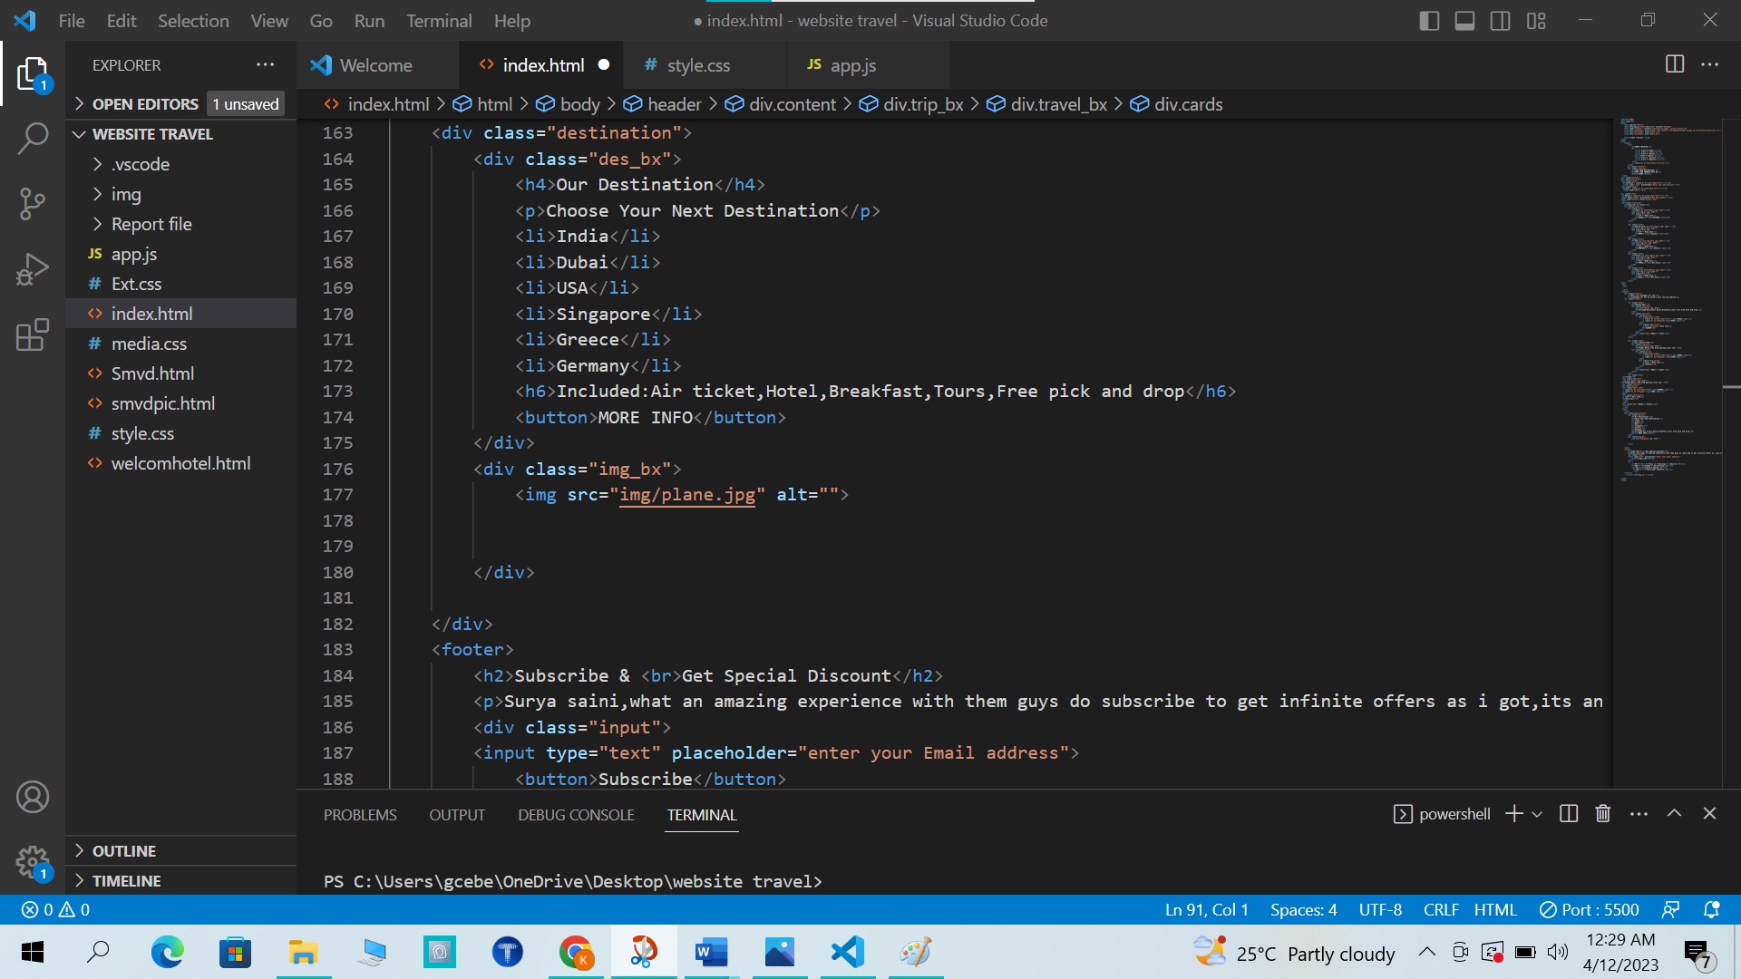

CSS FOR DESTINATION BOX:

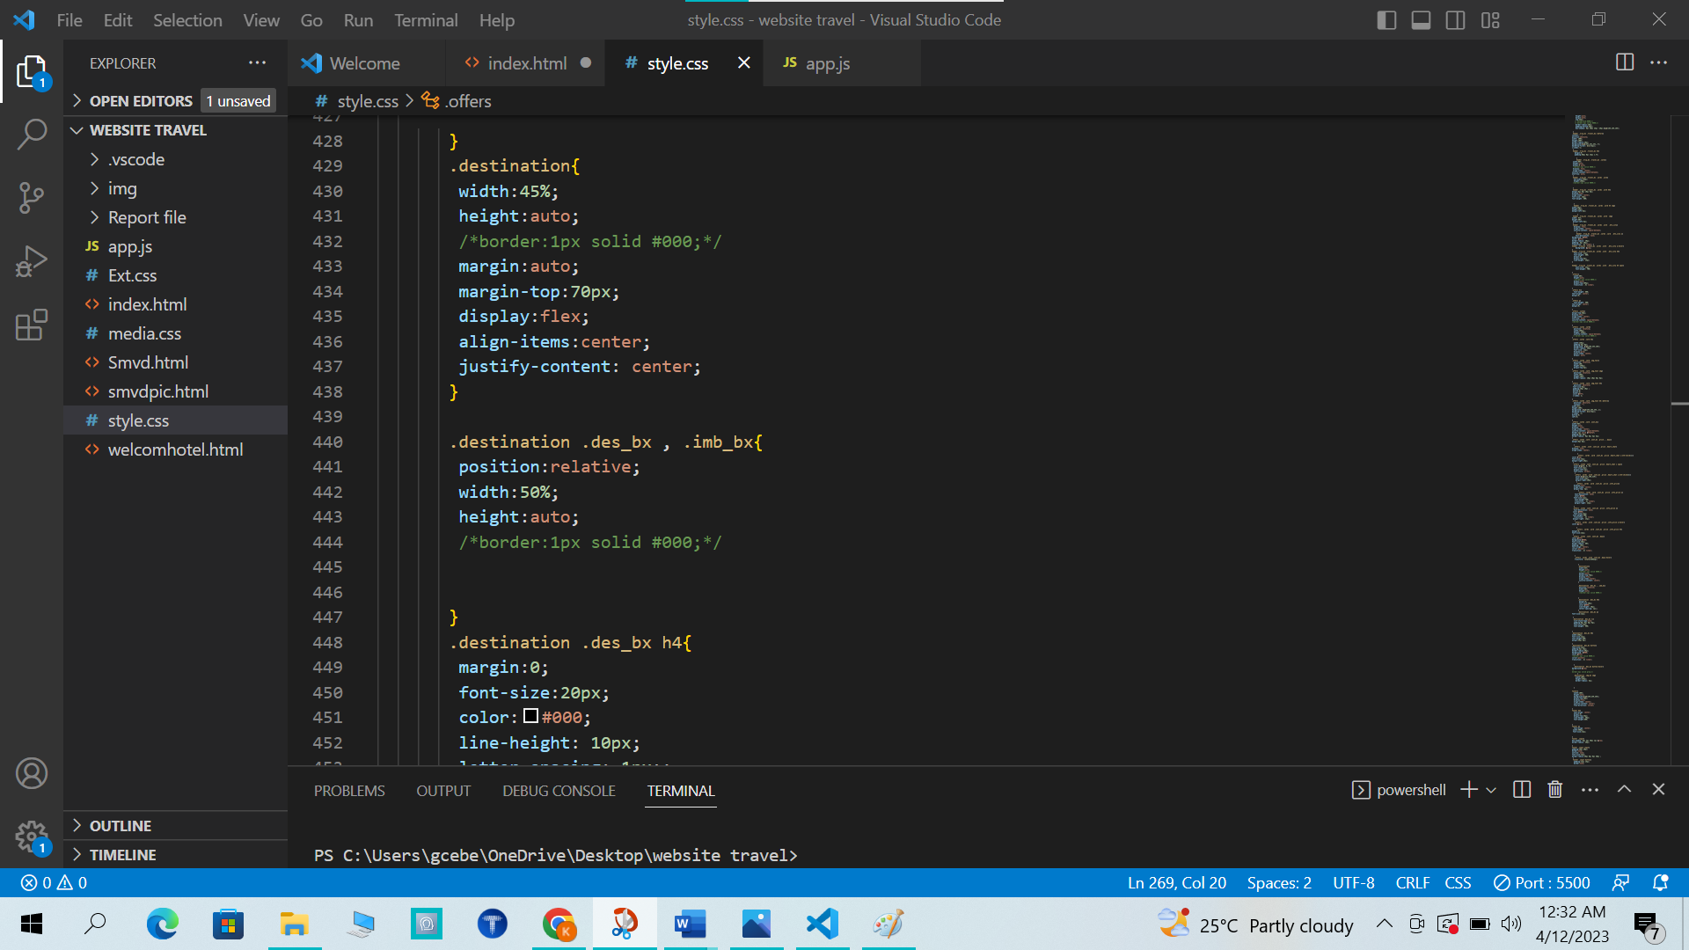 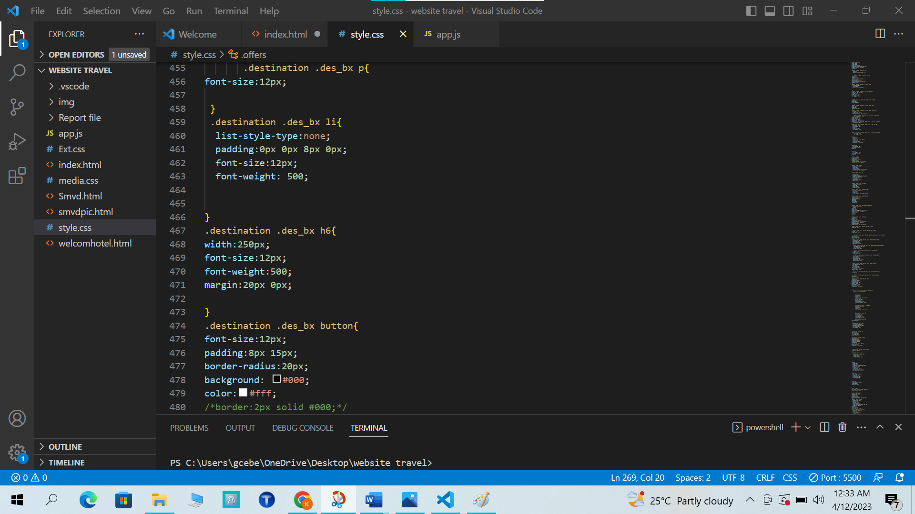 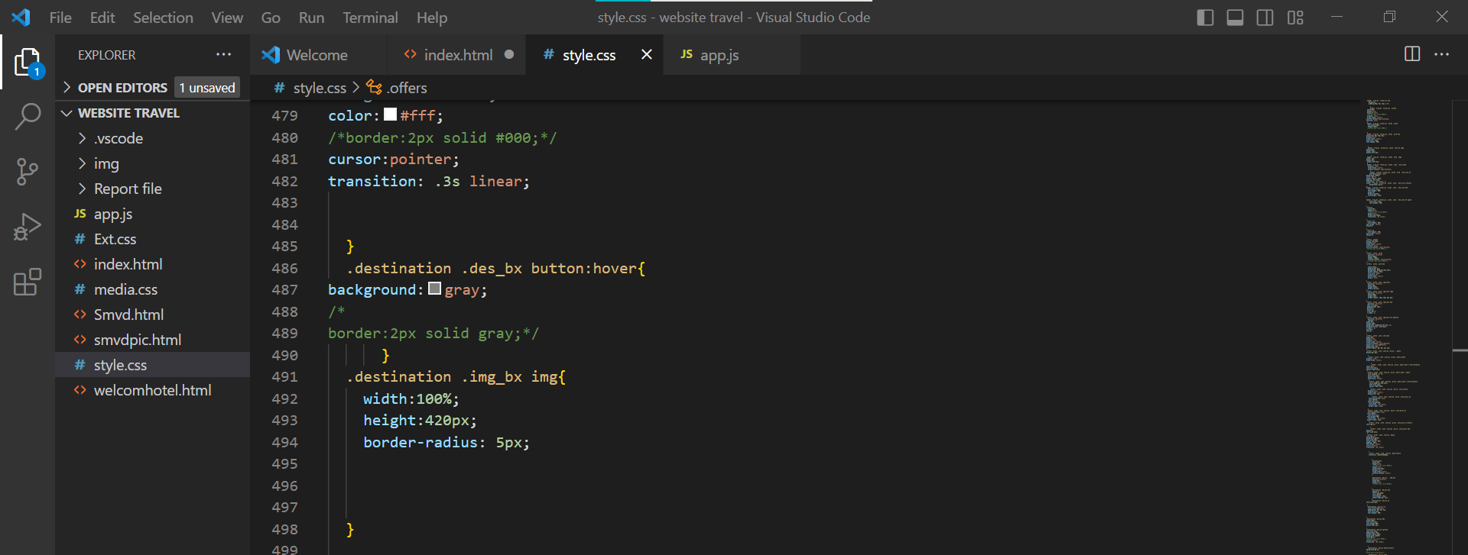

OUTPUT FOR DESTINATION BOX:

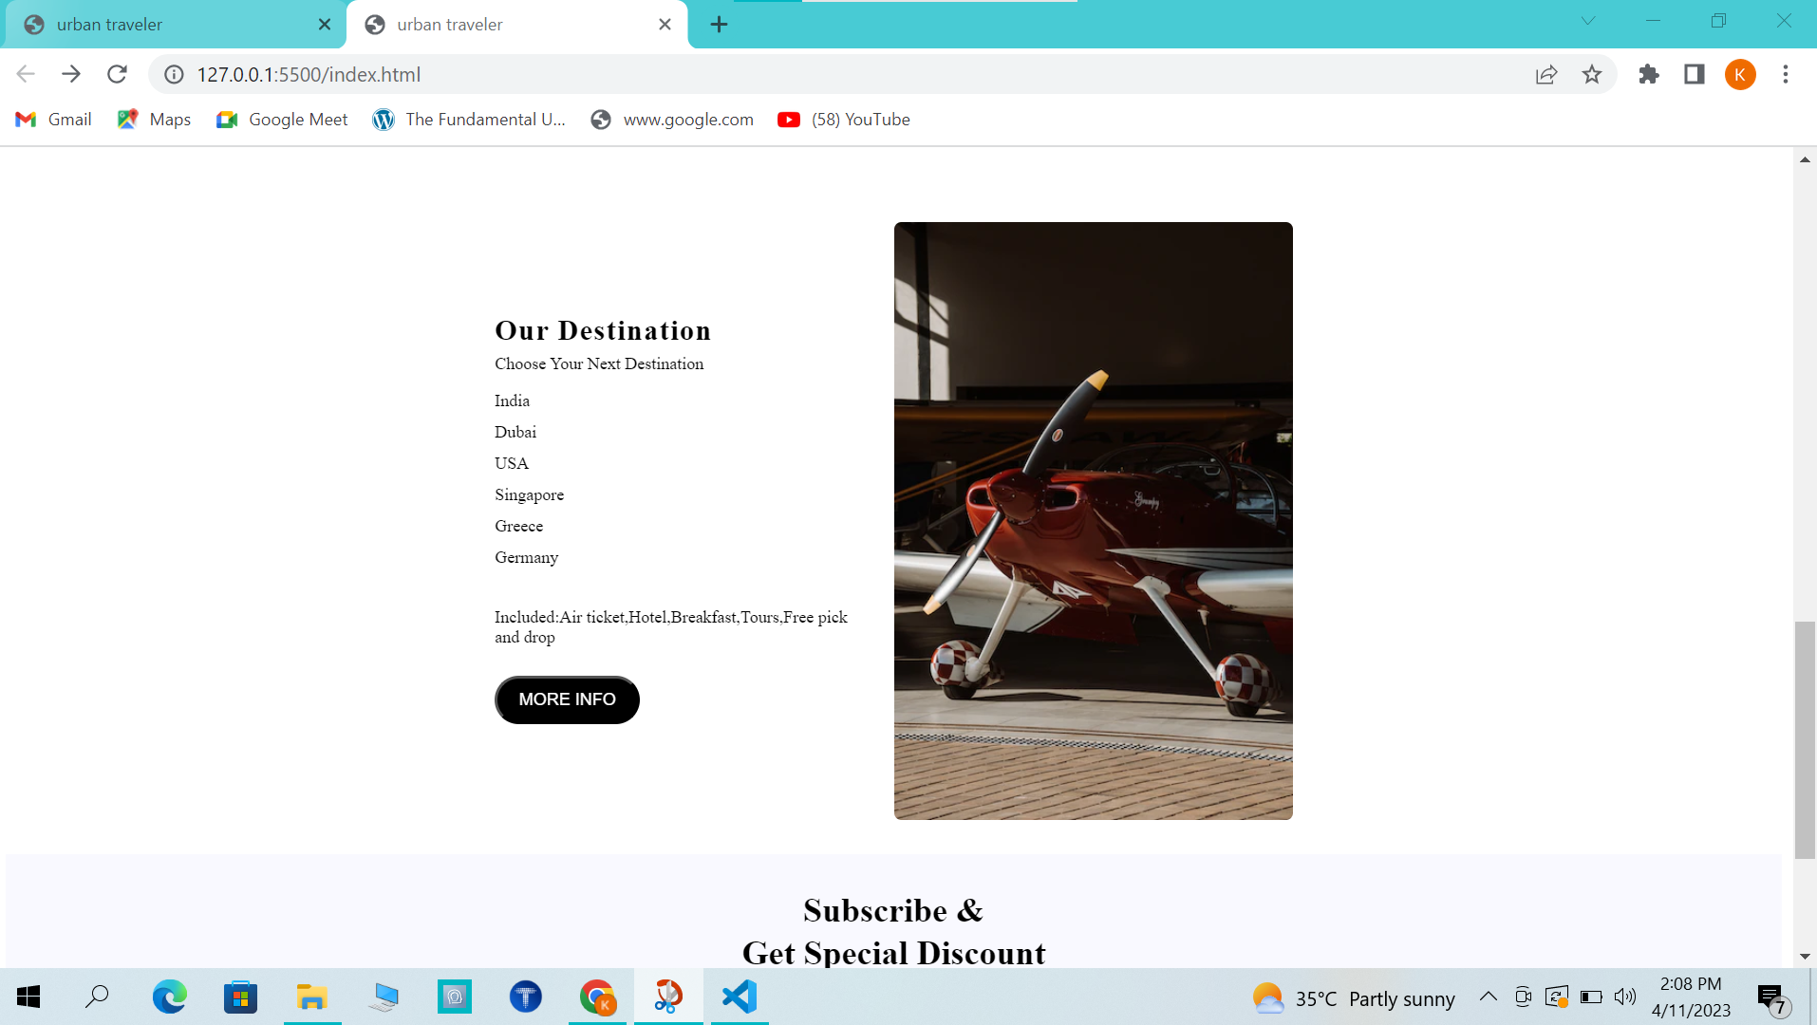

HTML FOR FOOTER:

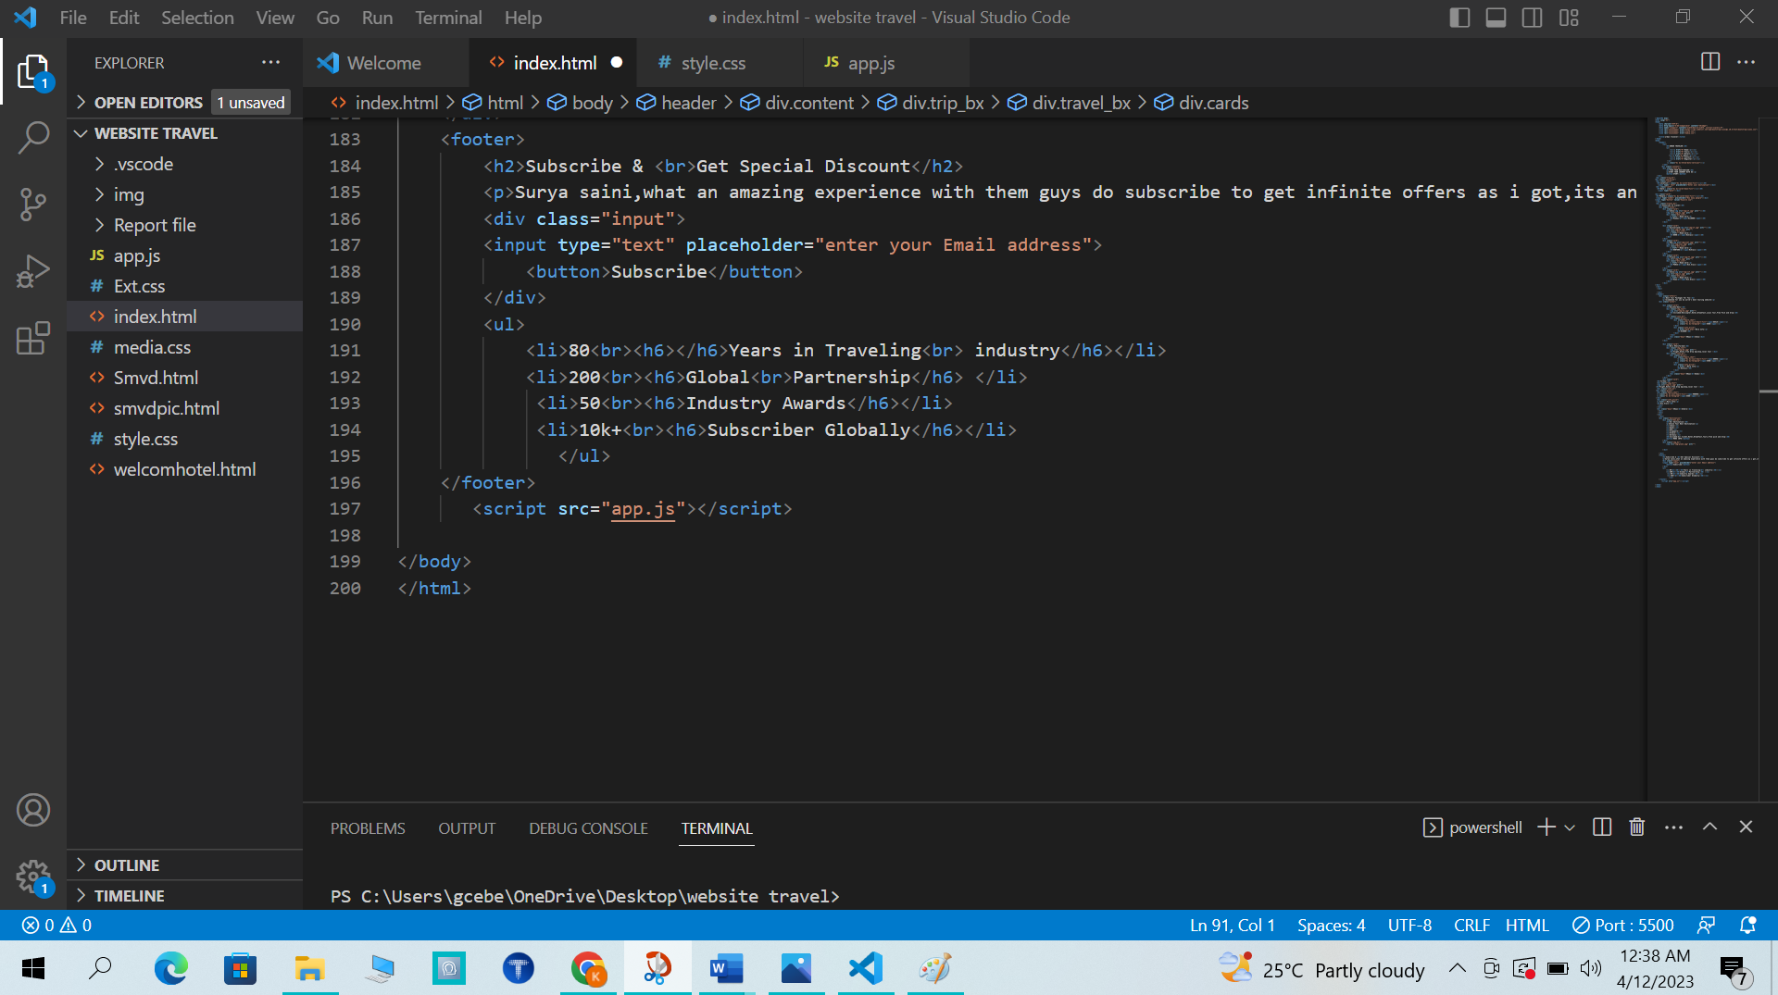

CSS FOR FOOTER:

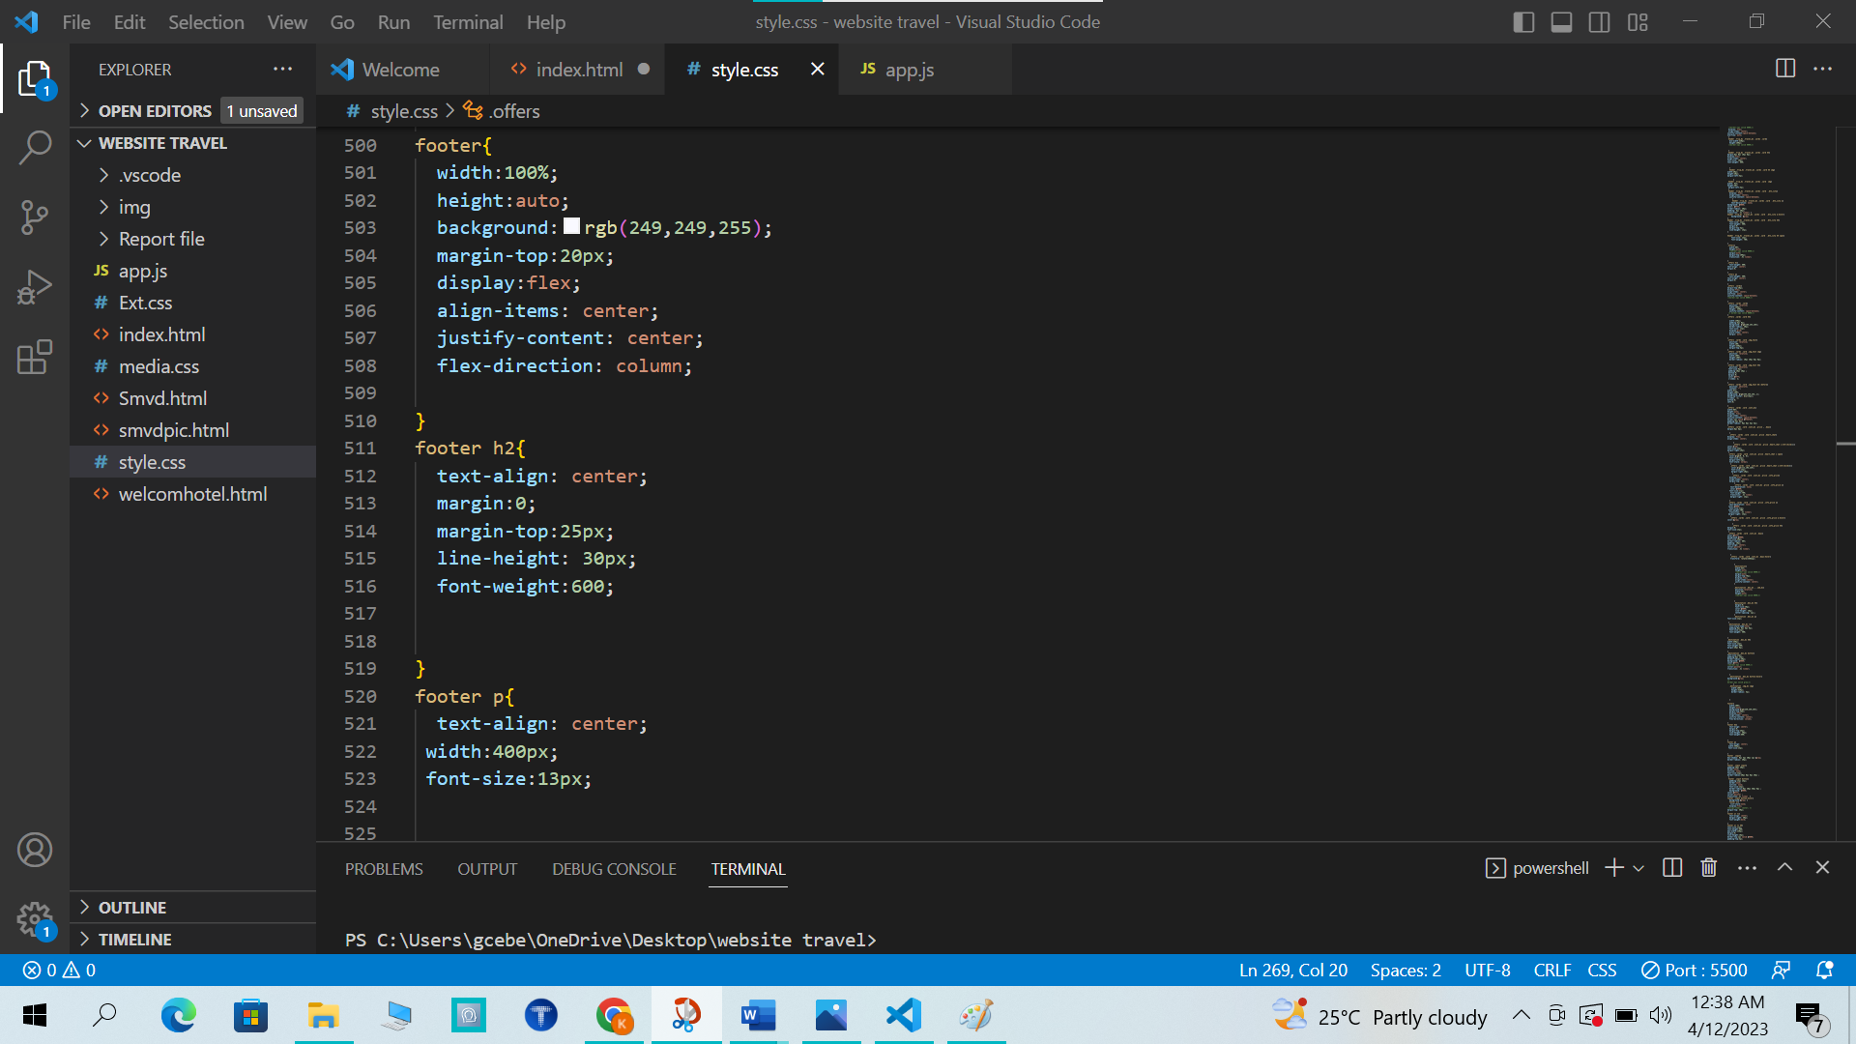

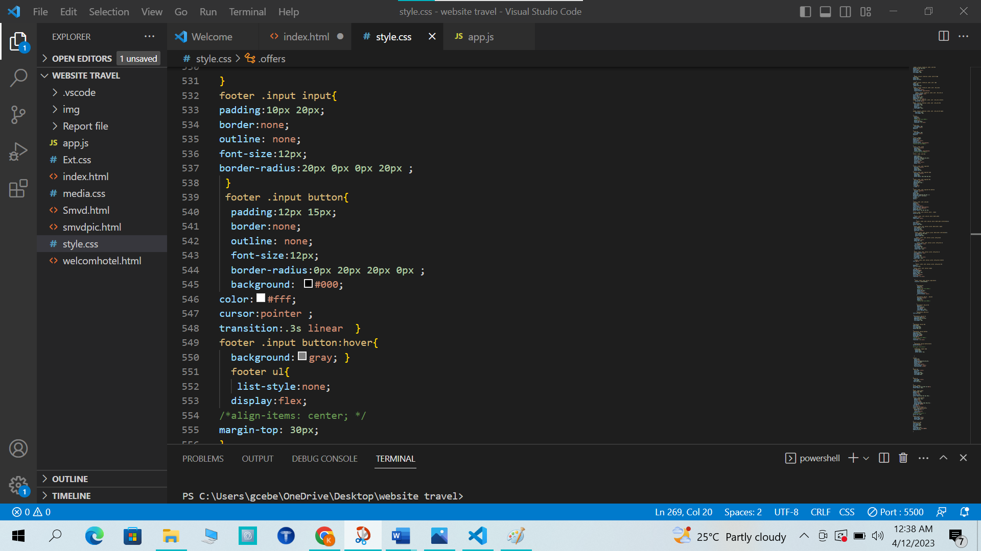

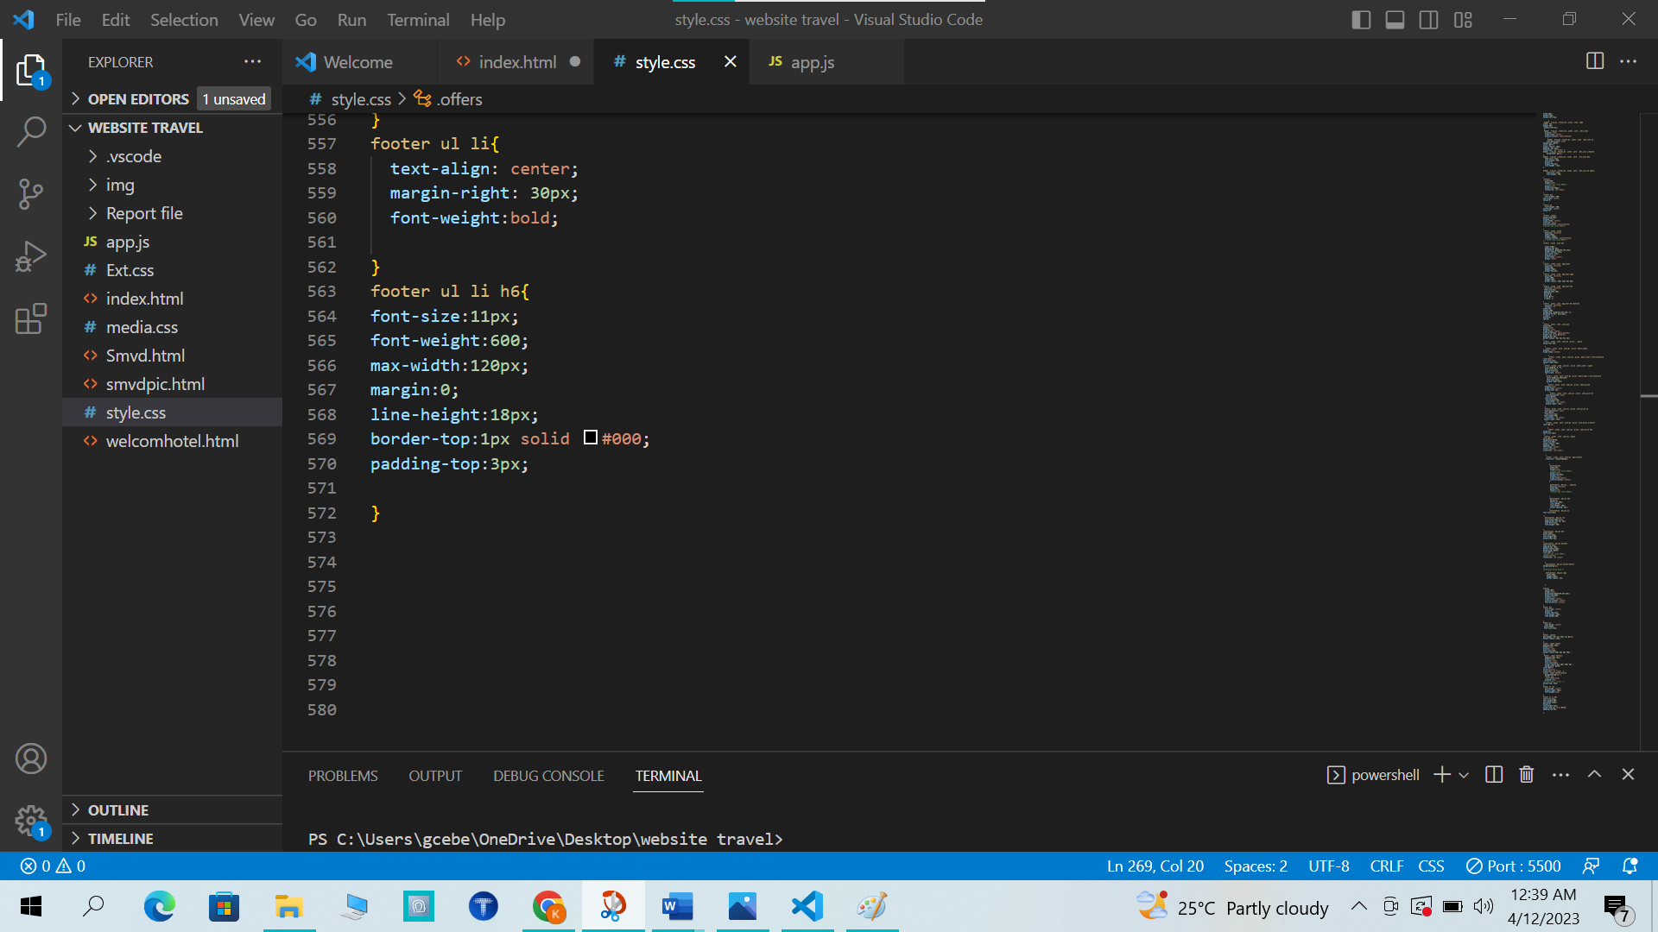

OUTPUT FOOTER:

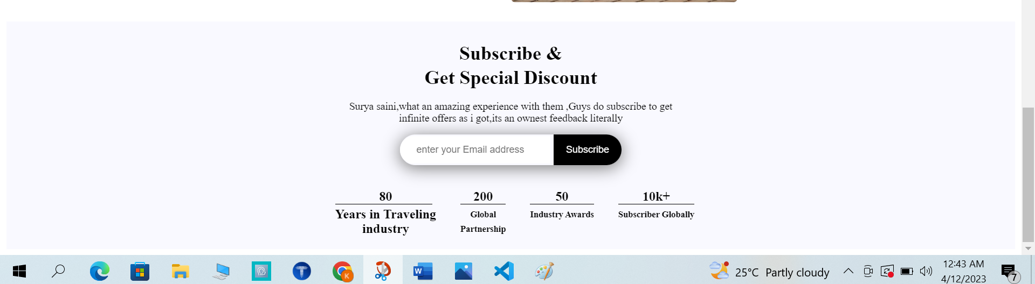

APPROACH USED:-

BOTTOM-UP

What is Bottom-Up Approach?

**Bottom-Up Approach** is one in which the smaller problems are solved, and then these solved problems are integrated to find the solution to a bigger problem. Therefore, it uses composition approach.

It requires a significant amount of communication among different modules. It is generally used with object oriented programming paradigm such as C++, Java, and Python. Data encapsulation and data hiding is also implemented in this approach. The bottom-up approach is generally used in testing modules.

CONCLUSION:

Here we have presented the design of a tour management system that can provide the users with the required tourism guidance required anytime and anywhere. This is a combination of smartphone and Internet services. The tour management website contributes a reasonable way for the users to schedule their trips, since it provides detailed information about the tourist places including description, image and map. This method includes various features/services such as delivering customized packages, the distance between the source and destination location, Google maps, online ticket booking, etc. This process achieves its main goal by pertaining to real-time data.

**SCOPE OF THE PROJECT:**

There are many scopes available in this field like –

* This type of software’s can be further extended for generating reviews

related to the tourist requirements.

* Also, can be used for generating reviews for the Online Videos provided on the software.
* Easy to find the nearby famous places, temples & monuments.
* Developer can be providing the update information of the places and also provide updates to the software for better serves.

BIBLIOGRAPHY:

[1] Sushil Bhardwaj, Puneet Kumar, Web Programming (2022).

[2]https://www.w3school.com

[3] https://www.Youtube.com